Reconciling the Government Travel Charge Card Statement with E2 fees and reservations.
The information below can be used to research Airfare Reservations, Travel Management Center fees (TMC) and Voucher Transaction Fees (VTF).
Below is an E2 reservation in the authorization, you will see the Ticket Number under Ticket Data and it matches the Merchant Code on the credit card statement for the $7.52 TMC Fee.
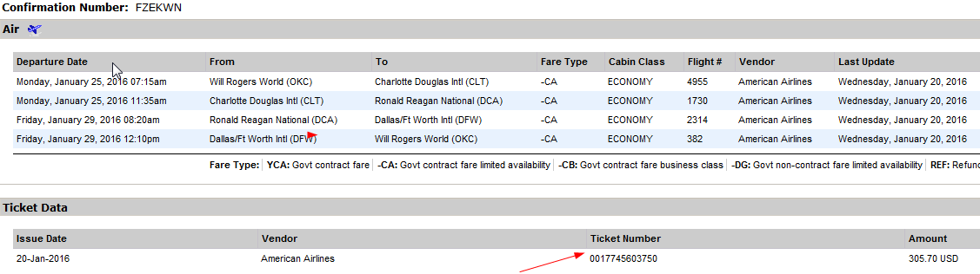
GOV Travel Card Statement shown below, if you Click on $7.52 TMC Fee or the dollar amount of the Airfare
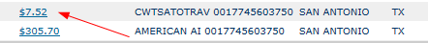
Another window will open (shown on next page) and next to Merchant you will see the number after CWTSATOTRAV, in this example, ending in 3750 is the E2 ticket number, for your reservation. This can be done for the airfare reservations as well.

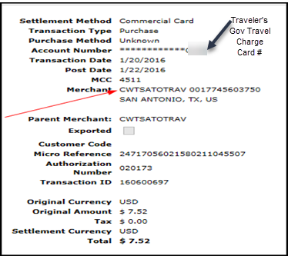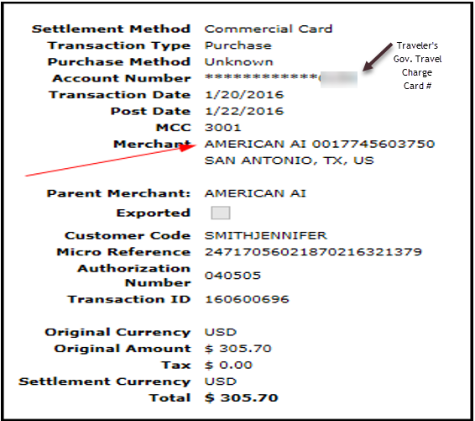
Below you will see the VTF fee as it appears on the credit card statement. The Customer Code indicates The Trip ID number of your Voucher.
Another way you can retrieve the information is by clicking on the dollar amount and the window below will open and next to Customer Code is the E2 Trip ID number.