Travel System Enhancements

Last Updated March 2019
Contents
E2 ENHANCEMENTS 3
1. Automated Addition of TMC Fees 4
2. Automated Reimbursement Type for Airfare Set Based on Reservations 5
3. Automatic De-Obligation of Travel Funds 6
4. Return Rejected Documents Back to the Traveler 7
5. Display of Fare Type Information with the Itinerary 7
6. Expedited Self-Service for Expired Passwords 9
7. Add air reservation to an existing hotel and/or rental car reservation 9
8. Cancel Air Reservations by Segment 11
9. Change Travel Dates on Voucher without an Amendment 12
10. New Reports – Transaction Fees and Booked Reservations 13
11. New Name for System-Generated Authorization, Voucher, and Local Travel Transaction Record 14
12. Delete Attachments 15
13. Improved Faxed Attachment Process 18
14. GetThere Keep Alive 20
15. Travel for Others Filter Option 20
16. Retain Voucher Expense after Trip Amendment 21
17. Increased File Attachment Size 24
18. Expand Document Return Options 25
19. Cancel a Reservation from within an Authorization 27
20. New User Interface 29
21. Edit Traveler Charge Card Information 31
22. New Authorization Amendment Summary View 32

E2 ENHANCEMENTS

Additional features and enhancements have been implemented in the Department’s travel management system, E2 Solutions. These enhancements improve and automate E2 processes, and change the look and feel of E2 for travelers, arrangers, and approvers in certain areas. The implemented enhancements to date are listed and are explained in further detail below:

- Automated Addition of TMC Fees
- Automated Reimbursement Type for Airfare Set Based on Reservations
- Automated De-Obligation of Travel Funds
- Return Rejected Documents Back to the Traveler
- Display of Fare Type Information with the Itinerary
- Expedited Self-Service for Expired Passwords
- Add Air Reservation to an Existing Hotel and/or Rental Car Reservation
- Cancel Air Reservations by Segment
- Change Travel Date on Voucher without an Amendment
- New Reports – Transaction Fees and Booked Reservations
- New Name for System – Generated Authorization, Voucher, and Local Travel Transaction Record
- Delete Attachments
- Improved Faxed Attachment Process
- GetThere Keep Alive
- Travel for Others Filter Options
- Retain Voucher Expense Data after Trip Amendment
- Increased File Attachment Size
- Expand Document Return Options
- Cancel a Reservation from within an Authorization
- New User Interface
- Edit Traveler Charge Card Information
- New Authorization Amendment Summary View

1. Automated Addition of TMC Fees
What is happening and why?

E2 will automatically populate a Travel Management Center (TMC) fee in the Expense list for the last reservation made via the online booking tool or with a TMC agent. Note, travelers are responsible for manually adding additional TMC fee expense(s) from previous reservation(s) or reservation changes to the voucher.

What will you notice?

The TMC fee, which previously had to be manually added in E2 by the traveler, will now be automatically added to both the authorization and voucher as described below:
- Authorization: E2 automatically populates an estimated TMC fee to the authorization expense list when a reservation is associated to an authorization.
- Voucher: The last TMC fee expense will be automatically updated on the voucher once the actual fee information is received from the ticket data. However, travelers must manually enter additional TMC fee expense(s) if multiple fees were incurred.
Note: TMC fees are not one-time fees and are charged every time travelers make or update reservations. If a traveler first makes air reservations prior to a trip then adds hotel reservations later, they are charged two separate TMC fees. Additionally travelers are charged an additional TMC fee each time they make a change to ticketed reservations. TMC fees are non-refundable and must be expensed when reservations are canceled.

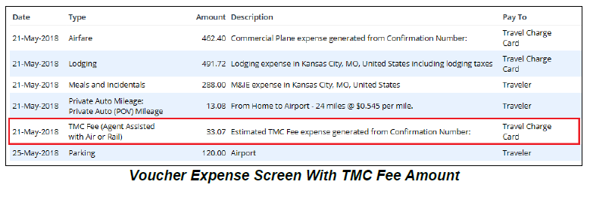

What actions do you need to take?

Travelers must cross-check TMC fees listed on the voucher to the travel invoice and traveler charge card (TCC) statement to validate all TMC fees are included on the voucher.

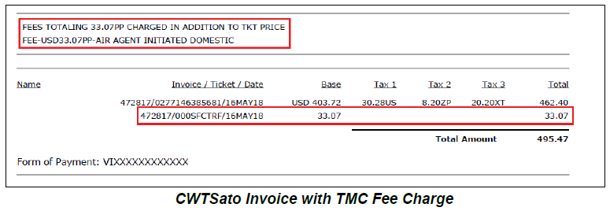

2. Automated Reimbursement Type for Airfare Set Based on Reservations
What is happening and why?

Reimbursement type (i.e., Traveler or Agency Billed) for airfare expenses will automatically default based on the method of payment associated with the reservation. With this enhancement, reimbursements will be directed to the correct account that paid for the airfare expense.

What will you notice?

E2 will automatically assign the “Pay To” value for an airfare expense on the authorization and voucher based on the method of payment used when the reservation was made. In most cases, the online booking payment default is TCC, which will default the “Pay To” value for the airfare expense to the Traveler. If the user does not have a TCC and the default is the Centrally Billed Account (CBA), the “Pay To” value for the airfare expense will default to Agency Billed.

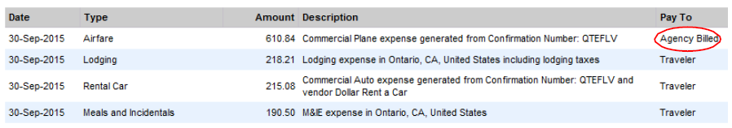
Airfare expense with defaulted Pay To value based on the method of payment
Changes made to airfare reservations on approved authorizations that result in the use of a different method of payment will not update the “Pay To” value on the authorization; however, the “Pay To” value will be updated on the voucher.

What actions do you need to take?

Travelers must maintain their TCC information and preferred payment methods for air, rail, and hotel charges at all times. These settings can be updated by accessing the Profile tab, clicking the Edit Travel Preferences link, and then clicking the Charge Cards link. Updates to these settings will reflect in new travel documents and will not update in open travel documents.

3. Automatic De-Obligation of Travel Funds
What is happening and why?

Approved authorizations will be automatically canceled if there is no voucher processed within 100 days after the trip end date. With this enhancement, funds will automatically be returned to the agency’s financial system when no voucher has been submitted.

What will you notice?

E2 will automatically send the traveler notifications at the following intervals when a trip that has ended is in Authorization Approved or Open Voucher status, or no voucher has been created:
- Reminder at 30 days – Initial reminder to alert the traveler that a voucher has not been processed as of 30 days after the trip end date.
- Warning at 60 days – Initial warning 60 days after the trip end date stating that the authorization will be canceled in 40 days if a voucher has not been processed.
- Final Warning at 90 days – Final warning 90 days after the trip end date stating that the authorization will be canceled in 10 days if a voucher has not been processed.
- Cancellation at 100 days – Notification to the traveler and final approver that the authorization has been canceled since a voucher was not processed within 100 days of the trip end date.
What actions do you need to take?

If you receive a reminder or warning notification in regards to a trip that was completed, you must submit a travel voucher before the date listed in the notification to avoid automatic cancelation of your travel authorization. If your trip is canceled, you will need to create a new authorization and voucher if you need to claim expenses for the trip.

4. Return Rejected Documents Back to the Traveler
What is happening and why?

Documents rejected by Delphi, DOT’s financial system, will be returned directly to the traveler. Prior to this enhancement, rejected documents were returned to either the first approver or the last approver. Now the traveler will have the ability to view the rejected document and the reason for rejection to complete edits themselves.

What will you notice?

E2 will send the traveler an email notification if a document is rejected. When the traveler views the rejected document, a warning message will appear at the top of the Summary page with the reason for the rejection. Any comments added by the E2 administrator will be available via the Remarks link, in OTHER ACTIONS, on the left side of the page.

What actions do you need to take?

If you receive an email notification regarding your document being rejected, please follow the instructions provided in the email to make the appropriate corrections to the document before resubmitting.

5. Display of Fare Type Information with the Itinerary
What is happening and why?

Authorizations and vouchers will display more detailed airfare reservation information, including fare types and rules (e.g., refundable or non-refundable). Travelers and approvers will have access to more information regarding airfare reservations when making reservations and approving travel documents.

What will you notice?

An additional column for Fare Type will be added for air reservations within the Reservation step of an authorization, and a legend to help travelers decode the fare type information will show below the air reservations.
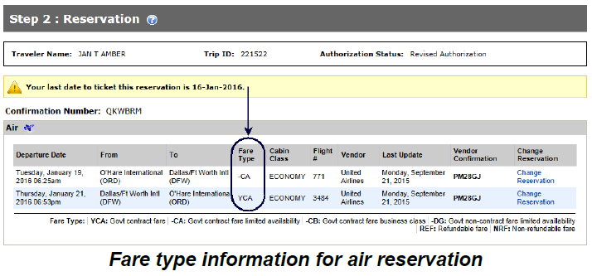

Fare type information will also be included in the following areas:
- After clicking the Manage Trip Reservations link at the bottom of the Reservation step, the Summary column will include the fare type information.
- The reservation section of the Trip Dashboard will include fare type information under the Description column.

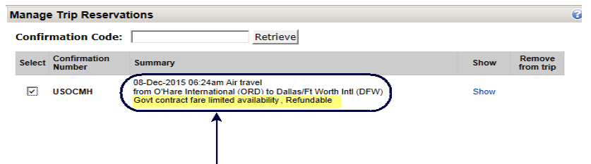
Manage Trip Reservations window showing fare type details

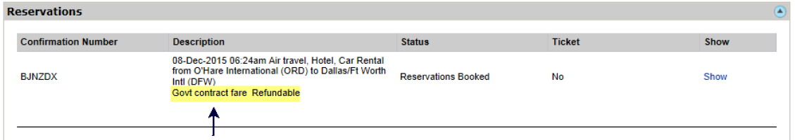
Reservations section of Trip Dashboard showing fare type details
- After clicking the Itinerary link in either OTHER ACTIONS on the authorization workflow or QUICK LINKS on the Trip Dashboard, the Class, Flight, and Seat column will include fare type.
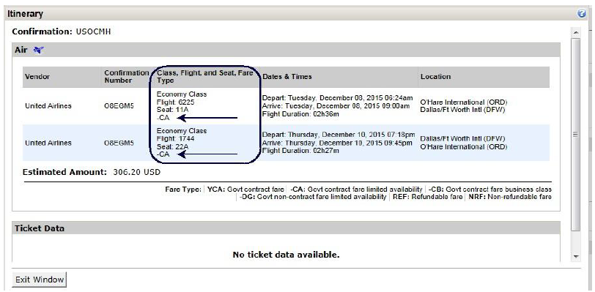
Itinerary window from Trip Dashboard showing fare type details

6. Expedited Self-Service for Expired Passwords
What is happening and why?

The self-service password reset process will become easier and faster. The initial step requiring a user to use an email link to reset an expired password will be eliminated.

What will you notice?

E2 will detect the expired password at the log in attempt and present the user with security questions. After entering the answers correctly and clicking Continue, the user will complete new security credentials (i.e., new password and security questions and answers), click Save, accept the Warning Message and Privacy Notice, and will be logged in to E2.

What actions do you need to take?

No action is required.

7. Add air reservation to an existing hotel and/or rental car reservation
What is happening and why?

Users will be able to either add an air reservation to (1) an existing hotel and/or car reservation, or (2) at the Trip Review and Checkout section at the end of the booking process. Users can also add a car or hotel reservation to an existing trip. Prior to this enhancement, users had to create a separate air reservation if they had booked a hotel and/or car reservation previously. Now users can easily add an air reservation to an existing trip without going through the process of creating a new reservation.

What will you notice?

From E2 the user will click Change Reservation to access an existing trip. Within the existing trip, an Add to Your Trip section will contain a dropdown for the user to select a hotel, air, or car to add to the trip. The user can also add a reservation at the Trip Review and Checkout section by clicking the Add to This Trip link.

What actions do you need to take?

Detailed instructions on how to use this enhancement are provided below:

If your reservation is not yet associated with an authorization:
- Click Show Held Reservations from the My E2 Trips tab. The Held Reservations window appears.
- Locate the reservation on the list and click Change. The online booking site appears.
- Use the Add to Your Trip drop down menu to select the changes you want, such as adding a flight, hotel, or rental car. The online booking site moves you through the process.
- After confirming your changes, you are automatically returned to E2 and prompted to create an authorization from the changed reservation or save it for later.
If your reservation is associated with an authorization that has not been submitted for approval:
- Locate the trip on the My E2 Trips tab. Click the Show link for the authorization to access the Authorization tab and workflow.
- Go to the Reservation step. Locate the reservation on the list and click Change Reservation. The E2 online booking site appears, showing your reservation information.
- Use the Add to Your Trip drop down menu to select the changes you want, such as adding a flight, hotel, or rental car. The online booking site moves you through the process.
- After confirming your changes, you are automatically returned to E2. Complete the authorization and submit it for approval.
If your reservation is associated with an approved authorization:
- You must amend your authorization and then change your reservation. Click Amend Authorization on the Trip Dashboard.
- Go to the Reservation step. Locate the reservation on the list and click Change Reservation. The E2 online booking site appears, showing your reservation information.
- Use the Add to Your Trip drop down menu to select the changes you want, such as adding a flight, hotel, or rental car. The online booking site moves you through the process. After confirming your changes, you are automatically returned to E2.
- Complete the workflow. You should always review Site Details to be sure they reflect the changed reservation information. Submit your amended authorization for approval.

8. Cancel Air Reservations by Segment
What is happening and why?

Users will be able to cancel flights individually for bookings that aren’t ticketed. This enhancement will give users greater flexibility and allow them to cancel a flight if their itinerary changes.

What will you notice?

Users will be able to cancel flights from the Trip Review and Checkout section in GetThere or by Accessing an Existing Trip in E2.

What actions do you need to take?

Users can cancel a flight in the Trip Review and Checkout section of GetThere by clicking the Remove This Flight link next to the particular flight. To access an existing trip in E2, the user would click Change Reservation.
Detailed instructions on how to use this enhancement are provided below:

If your reservation is not yet associated with an authorization:
- Click Show Held Reservations from the My E2 Trips tab. The Held Reservations window appears.
- Locate the reservation on the list and click Change. The online booking site appears.
- Under the Traveler Information section, each flight will have a Remove This Flight link. Click the Remove This Flight link to cancel individual air segments without canceling the entire booking. The online booking site moves you through the process.
- After confirming your changes, you are automatically returned to E2 and are prompted to create an authorization from the changed reservation or save it for later.
If your reservation is associated with an authorization that has not been submitted for approval:
- Locate the trip on the My E2 Trips tab. If necessary, click the Show link for the authorization to access the Authorization tab and workflow.
- Go to the Reservation step. Locate the reservation on the list and click Change Reservation. The E2 online booking site appears, showing your reservation information.
- Under the Traveler Information section, each flight will have a Remove This Flight link. Click the Remove This Flight link to cancel individual air segments without canceling the entire booking. The online booking site moves you through the process.
- After confirming your changes, you are automatically returned to E2. Complete the authorization and submit it for approval.
If your reservation is associated with an approved authorization:
- You must amend your authorization and then change your reservation. Click Amend Authorization on the Trip Dashboard.
- Go to the Reservation step. Locate the reservation on the list and click Change Reservation. The E2 online booking site appears, showing your reservation information.
- Under the Traveler Information section, each flight will have a Remove This Flight link. Click the Remove This Flight link to cancel individual air segments without canceling the entire booking.
- Complete the workflow. You should always review Site Details to be sure they reflect the changed reservation information. Submit your amended authorization for approval.

9. Change Travel Dates on Voucher without an Amendment
What is happening and why?

Users will be able to change departure and return dates, and sites information directly from a final voucher, without requiring an amendment to the authorization.

What will you notice?

When completing a final voucher, users can modify departure and return dates and sites on the Basic Information page. Select Final Voucher and Update Site Details option from the ‘For This Trip This Is The’ dropdown list located at the bottom of the Basic Information page.
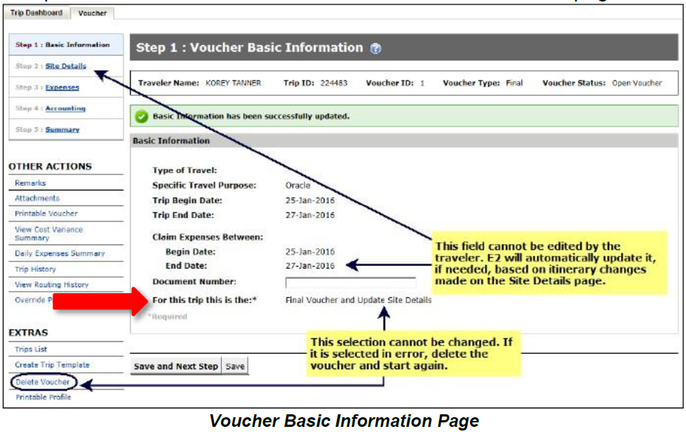

After the Basic Information page is saved, the Claim Expenses between End Date field is locked and the traveler is directed to the Site Details step in the voucher workflow. If date or site changes were made in error, delete the voucher and start again.

Note: The adjusted voucher becomes the final voucher for the trip and the voucher cut-off date will update to reflect the new trip end date. In some situations, itinerary changes may impact information that cannot be updated on the voucher, such as a reduced expense amount for meals and incidentals. In this situation, users should amend the authorization to include the itinerary changes and update associated information (i.e., expenses). Once the amended authorization is approved, users can submit a final voucher for approval. Users cannot make itinerary changes that impact trip vouchers already submitted for approval. All other site detail changes are permitted.

What actions do you need to take?

Users should include in the Remarks section of the voucher an explanation for the changes (i.e., meeting ended early). The Remarks link is located under the OTHER ACTIONS column.

10. New Reports – Transaction Fees and Booked Reservations
What is happening and why?

Two new reports will be available in the Reports feature in E2 to review transaction fees and booked reservations.

What will you notice?
- Transaction Fees (FIN005I): This is an interactive report that provides voucher transaction fees (VTF) and TMC fees for vouchers or local travel claims in Closed or Awaiting Payment statuses only. Administrators can utilize this report to view information about travelers, trips, and local travel claims that include transaction fee expenses. This report can be filtered to show transaction fees associated with account codes for specific funding organizations. Note, the data in this report is refreshed overnight.

- Booked Reservations (RES004I): This is an interactive report that provides information about booked reservations, including the traveler name, confirmation number, booking and departure dates, and the last date to ticket. This report does not contain reservations booked directly by the TMC that have not been retrieved into E2 by the traveler. Note, this report contains live data and is updated in real-time.
What actions do you need to take?

The Transaction Fees report requires, at a minimum, minor level report access. For additional information regarding the reports, search and review the Report Catalog via Find Answers.

11. New Name for System-Generated Authorization, Voucher, and Local Travel Transaction Record
What is happening and why?

E2 generates and automatically attaches a printable record to travel documents (i.e., authorization, voucher, local travel) after final document approval. This printable record is available to users from the document Summary page, in the Remarks and Attachments section.

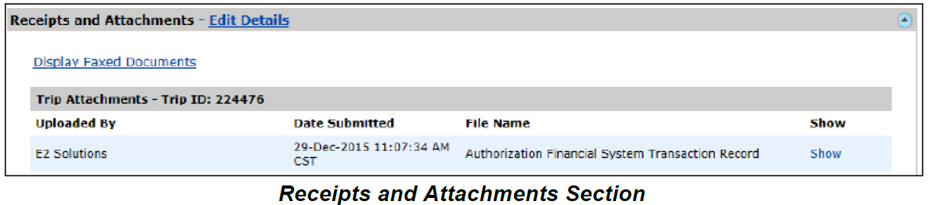

Previously titled Printable <document> (i.e., Printable Authorization) will display as <document> Financial System Transaction Record (i.e., Authorization Financial System Transaction Record) to better reflect the content and purpose of the file.

What will you notice?

Documents that receive final approval will have a <document> Financial System Transaction Record file attached in document Summary page. No changes will be made to any existing printable records and will remain attached from the same location.

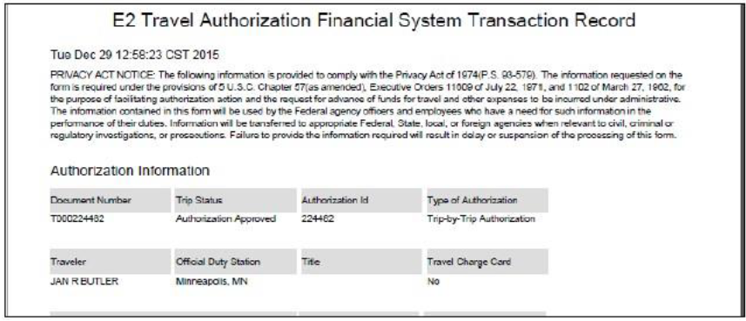
Printable Authorization Financial System Transaction Record

What actions do you need to take?

No action is required.

12. Delete Attachments
What is happening and why?

Travelers, approvers, and arrangers will be able to delete attachments, including faxed and expense- level attachments, from all E2 document types. The delete option does not apply to system-generated attachments.

What will you notice?

E2 will log an entry in the history file whenever a user adds or deletes an attachment. Attachments added to a trip prior to release 16.2 will not have a corresponding history entry notating when the attachment was added. However, if the attachment is deleted after release 16.2 is deployed, E2 will record a history entry for the deletion.

What actions do you need to take?

To delete an attachment, follow the steps below:
Trip Level Attachments
- Access the Receipts and Attachments section of the Summary page.

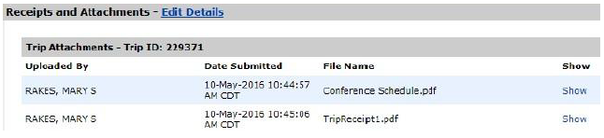

- Click the Edit Details link. The Trip-Level Attachments window appears. Click the Delete link to remove uploaded or faxed files. A prompt will appear to confirm the action.

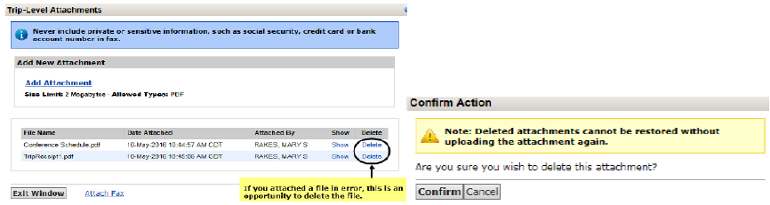

- Click Exit Window when you are finished. Adding and deleting attachments will add entries to the trip history file.

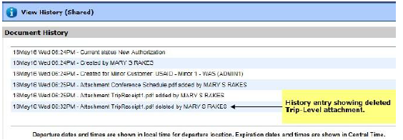
Expense Level Attachments
- Locate the expense on the list and click the Modify link. The Edit Expense window appears, showing the Detail tab by default.

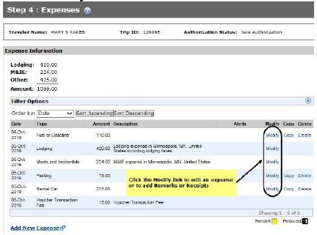

- Click the Receipts tab. If there are existing receipts, they will appear in the list. Click the Delete link to remove the file.

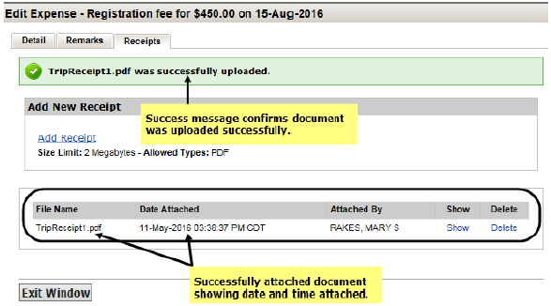

- Click Exit Window when finished. Deleting receipts will add entries to the document history file. However, if you delete an expense, including an expense that also has attached receipts, no entry will be added to the document history file.
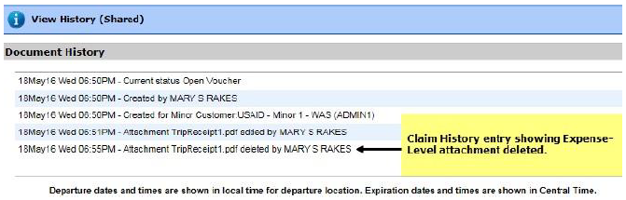

13. Improved Faxed Attachment Process
What is happening and why?

The E2 fax feature will allow the automatic addition of faxed attachments to a trip or local travel claim. This will automate retrieval of faxed documents directly into travel documents. Faxed documents will appear within 30 minutes of transmission and are automatically listed along with uploaded attachments. As explained above, faxed attachments can also be deleted. See Delete Attachments for more information. Additionally, E2 logs an entry in the document history file when a user attaches a document via fax or deletes a faxed attachment.

What will you notice?

The Display Faxed Documents and Retrieve Faxes links are no longer necessary and have been removed. Faxes attached to documents prior to the 16.2 production deployment will be migrated through the new fax tools and will automatically be available after the16.2 deployment from the document’s Attachment link or via the Receipts and Attachments section of the document Summary page.

What actions do you need to take?
- Click the Attachments link in the OTHER ACTIONS section. The Trip-Level Attachments window appears.

- Click the Attach Fax link. The Fax Attachment(s) section appears.
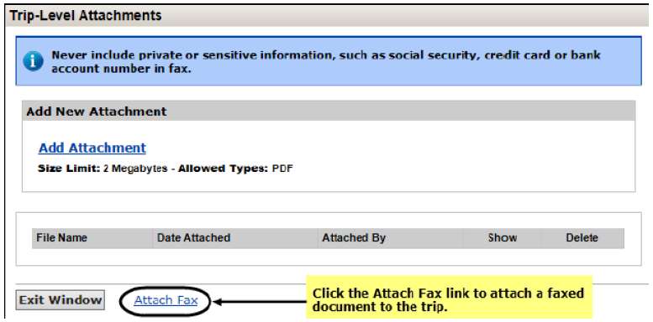

- Click the Print the Fax Cover Page link. A printable version of the cover sheet appears.

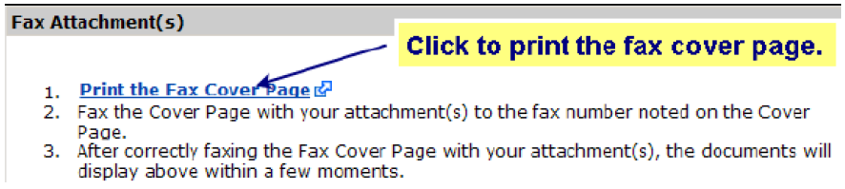

- Click Print This Page.
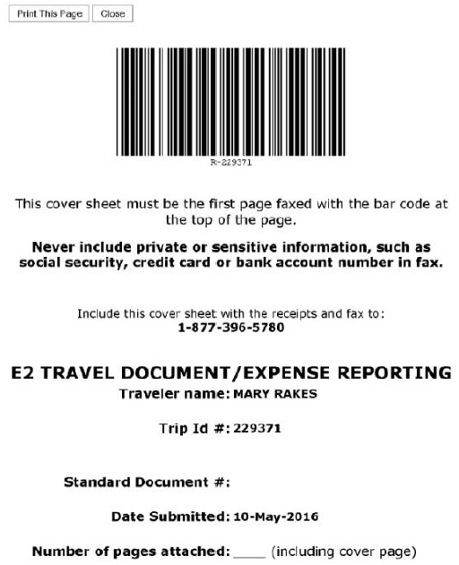
- Fax the cover page, along with the information you want to attach to the document, to the number shown on the fax cover page.
- The system will retrieve the faxed document from the vendor and attach the document(s) in the trip or local travel claim within 30 minutes after transmittal. The faxed attachment will not include the fax cover sheet.

14. GetThere Keep Alive
What is happening and why?

E2 sessions for the online booking tool, GetThere, will remain active for up to 60 minutes while selecting, modifying, and reviewing travel reservations. This will allow users to complete travel reservation related tasks without interruption.

What will you notice?

This enhancement extends your session time in GetThere. You will return to the E2 login page once you exceed the time limit; however, your reservations changes will save. New reservations will display in the held reservations section until you associate them with a travel authorization. If you log out of GetThere without making, modifying, or canceling a reservation, no reservation changes will appear in E2.

What actions do you need to take?

No action is required.

15. Travel for Others Filter Option
What is happening and why?

For arrangers, the Travel for Others section will automatically display the full list of travelers they are designated to arrange travel for with their current access permissions. This will allow arrangers easier access to travelers.

What will you notice?

The “Only show travelers for whom you are designated travel arranger” will be unchecked as the default, and the page will show the full list of assigned travelers (e.g., for an arranger with minor customer access, all travelers in the arranger’s minor customer).
Travel for Others Page View for Arrangers

What actions do you need to take?

No action is required.

16. Retain Voucher Expense after Trip Amendment
What is happening and why?

Previously, when amending an authorization for an “in progress” voucher (i.e., a voucher in an Open or Revised status), the amendment process deleted the initial voucher. This enhancement provides users with two options to copy over expense changes and settings onto the final voucher. The user will have the option to use expenses from the amended authorization or in progress voucher. This will save users time and reduce the amount of rework to complete the final voucher.

What will you notice?

When you are creating a voucher after amending an authorization, you will have two options to select from for Transportation and Other (T&O) Expenses on the Basic Information workflow step:
- Use Only Approved Amendment Expenses, or
- Use Only Pre Amendment Voucher Expenses.
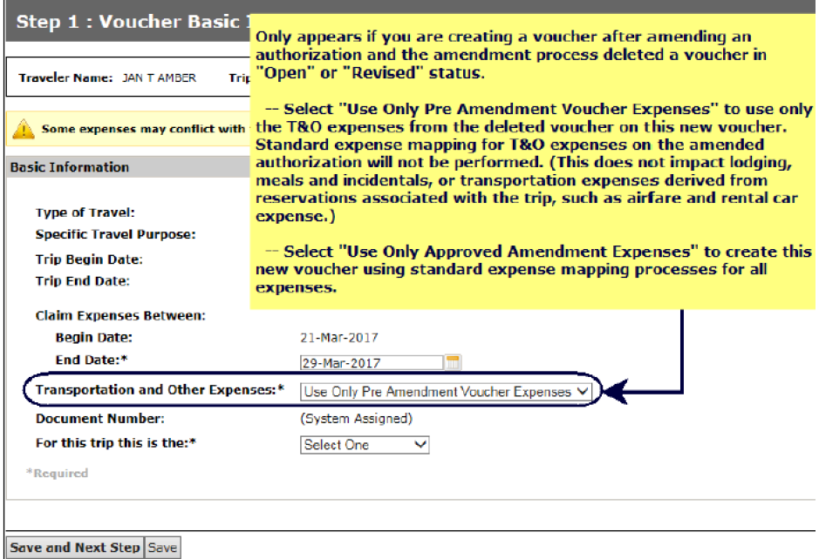
Voucher Basic Information Page

What actions do you need to take?

If you amend an authorization and would like to use this feature, follow the steps outlined below:
- Create a new voucher after the authorization amendment is approved.
- Decide what T&O expense option to select on the voucher Basic Information workflow step.
- “Use Only Approved Amendment Expense.” Examples of when this option could be used include:
  - Copying over mileage and other expenses estimated on authorization,
  - Retaining expense mapping settings as adjusted on the authorization, and
  - Copying over travel expenses not captured in E2 reservations that were entered on the authorization (i.e., booked outside of E2).
- “Use Only Pre Amendment Voucher Expenses.” This option uses only the T&O expenses from the “in progress” voucher on the new voucher. Previously, the “in progress” voucher expenses would delete during the amendment process. Associated remarks and attachments are also included. Estimated T&O expenses from the amended authorization will not map to the new voucher. An example of when this option could be used is provided below:
Example for “Use Only Pre Amendment Voucher Expenses”
A user created a voucher with POV and lodging tax in the expenses. However, the user realized they did not request actual lodging for the first day.

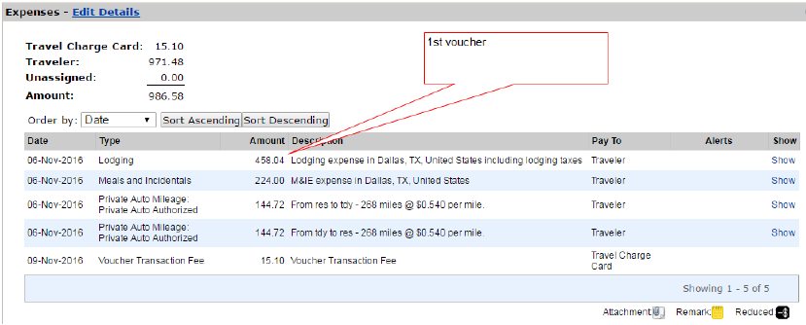
In Progress Voucher Expense Page

The user is required to amend the authorization to include actual expenses. The user adds the actual lodging for the first day along with taxes for each day of lodging.

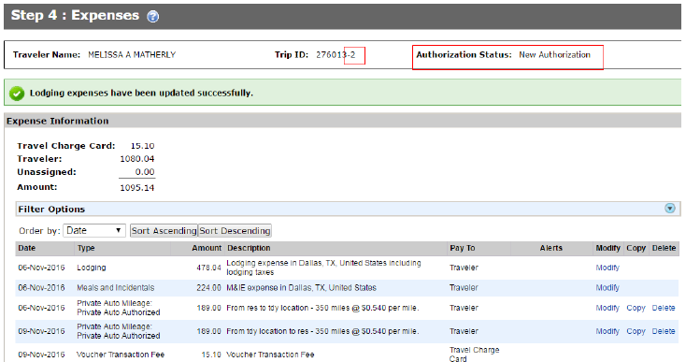
Amended Authorization Expenses Page

The user creates a second voucher and updates the basic information after the authorization amendment is approved.

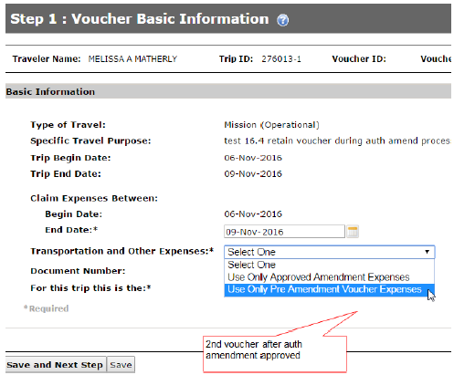
Basic Information Page for Updated Voucher

The user selects “Use Only Pre Amendment Voucher Expenses” for T&O expenses. The expense screen on the second voucher displays the Pre-Amendment Voucher Expenses along with the lodging expense change that completed on the authorization amendment.

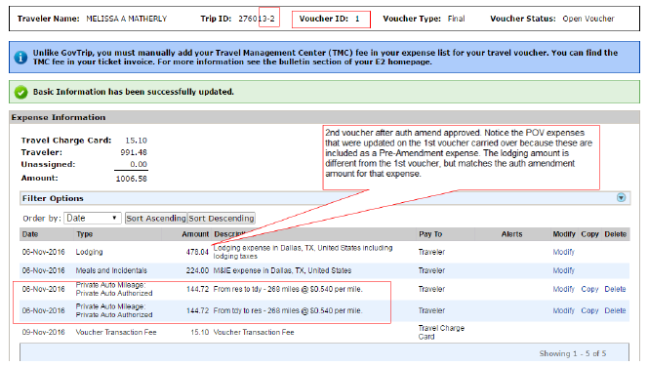
Updated Voucher Expense Page

The user completes the remaining steps and submits the second voucher for approval.

17. Increased File Attachment Size
What is happening and why?

The attachment size restriction on supporting documentation for vouchers will increase from two Megabytes to ten Megabytes. To date, travelers have generally had to attach multiple receipt files due to attachment size limitations. This new enhancement will allow E2 users to attach a single, larger attachment that contains multiple receipts, which not only reduces the amount of effort travelers invest in attaching receipts, but reduces the number of files an approver needs to open as part of the review process. E2 users can also continue to upload multiple documents, if preferred.

What will you notice?

This enhancement will be available for (1) trip-level attachments when submitting authorizations and (2) expense receipts when adding or editing voucher expenses.
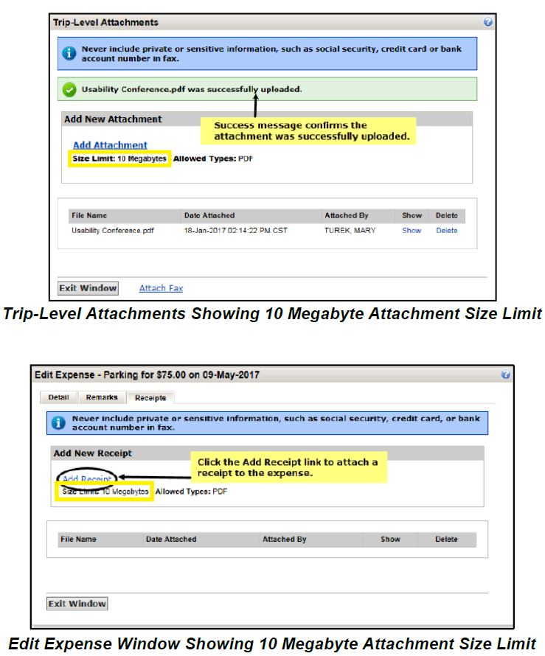

This enhancement will not impact existing limitations to the number of attachments allowed for trip attachments (i.e., no limit) and expenses (i.e., limited to five).

What actions do you need to take?

No action is required.

18. Expand Document Return Options
What is happening and why?

Approvers now have the option to return any document type (e.g., Authorizations, Advances, Local Travel Claims, Vouchers, etc.) to the traveler or to any prior approval level for revision. To date, approvers could only return documents to travelers. The document must then go through all prior levels of the approval process again before the document reached the final approval step. This new enhancement will allow E2 users to target the specific revision and associated approval level, which not only reduces the amount of effort for travelers and approvers, but also reduces the overall approval processing time. Approvers may also continue to return documents to the traveler for revision.

What will you notice?

Email Notifications
When a document is returned to the traveler for revision, an email notification is sent to the traveler. When a document is returned to the primary approver, an email notification is sent to both the traveler and the approver. If the routing pool does not have a primary approver, an email notification is sent to all members of the routing pool. This will keep the traveler informed about the status of the document.

Trip History
When a document is returned to the traveler or a prior approval level, the return is documented in the Routing History as shown below. This will help travelers and approvers track the document through the approval process.
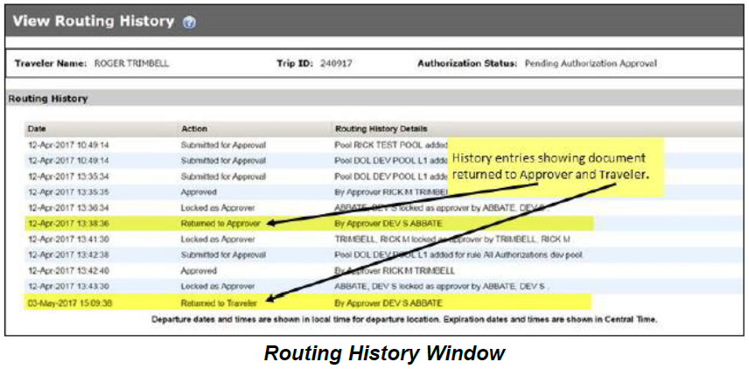
Document Status
When a document is returned to a prior approval level, the document status will remain as “Pending Approval” or “Pending Approval (Rejected by Agency).” When a document is returned to the traveler, the status of the trip will display as “Revised.” All voucher expenses will remain attached to the voucher when it is returned to a prior approval level. This will help ensure the traveler is reimbursed correctly.

What actions do you need to take?

The following steps must be completed to return a document to the traveler or any prior approval level:
- Click the Return button at the bottom of the Summary page. A Confirm Action window will appear.
  - 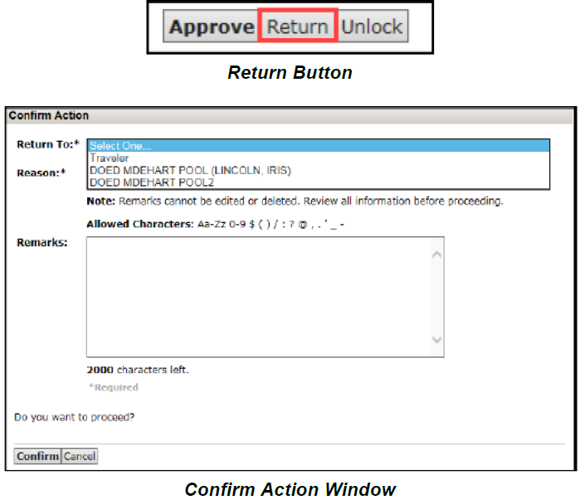
- Select the person or group to whom the document will be returned.
- Select the reason for returning the authorization from the Reason drop-down list.
- Enter any necessary remarks in the Remarks field.
- Click Confirm to return the document.

19. Cancel a Reservation from within an Authorization
What is happening and why?

Users will have the ability to cancel a reservation directly from the Manage Trip Reservations window. Prior to this enhancement, users could only cancel a reservation through the Held Reservations window, as the Manage Reservations window only allowed users to remove reservations. This created a usability concern as users often misunderstood the function of the Remove link (i.e., users believed that removing a reservation was equivalent to canceling the reservation). Travelers who attempted to cancel a reservation using the Remove link would then be penalized for reservations not properly canceled in a timely manner. Now, users can easily cancel all components of the reservation (i.e., air, hotel, rental car) without any confusion or additional steps.

What will you notice?

A Cancel Reservation column has been added with a Cancel link in the Manage Trip Reservations window. Selecting the Cancel link cancels the reservation and removes it from the authorization.
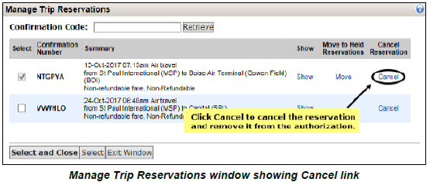

What actions do you need to take?

Complete the following steps to cancel a reservation from the authorization:
- From the Reservation window, click the Manage Trip Reservations link.
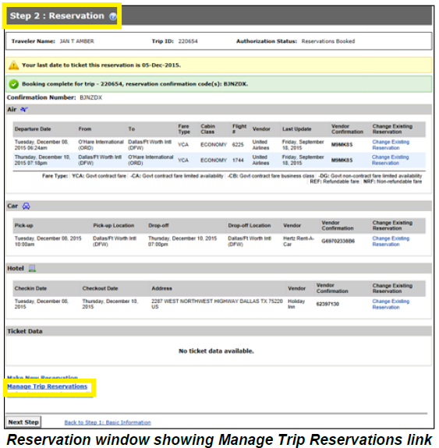
- Click Cancel to completely cancel the corresponding reservation and remove it from the authorization. The authorization will still remain available.
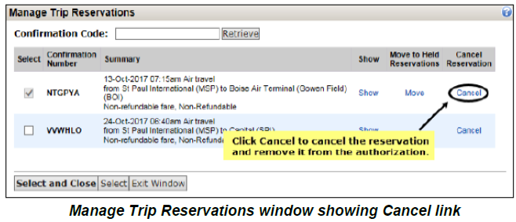
Note: If you only need to cancel some reservation components, you should change the reservation. For more information on changing reservations, refer to QRC23 Changing Reservations or search for answer 4175 via E2 Find Answers.
- When the Cancel link is selected, a Confirm Action window displays to warn you that canceled reservations cannot be restored. Click Confirm to continue and cancel the reservation. When the reservation is canceled, you are automatically returned to the Manage Trip Reservations window.
- Click Exit Window to close the Manage Trip Reservations window and return to the Reservation step.

20. New User Interface
What is happening and why?

E2 users will see a new interface that is more closely aligned to modern commercial travel-booking sites. This change will improve the users’ travel booking experience by providing more efficient ways to navigate E2 and manage travel.

What will you notice?

The new E2 interface provides a clean and streamlined design. Users will see changes to the following areas within E2:
- Updated colors, fonts, icons, and page layout styles;
- Improved Collapse and Expand section indicators;
- Clearer wording for making reservations and creating authorization actions (e.g., replaced the Quick Links list on the At a Glace tab with a Start a Travel Document section, changed the Shop First option to Make Reservations);
- Added yellow highlighting on the unsuccessful login message that appears at the top of the page (e.g., Your last login was Wed, 31 Jan 2018 3:17 PM CST. There have been 2 unsuccessful attempts since your last login.); and
- Added a new design to the Remarks section replacing the alternating blue and white rows with blue speech bubbles.
The screenshots below provide a preview of some of these changes.

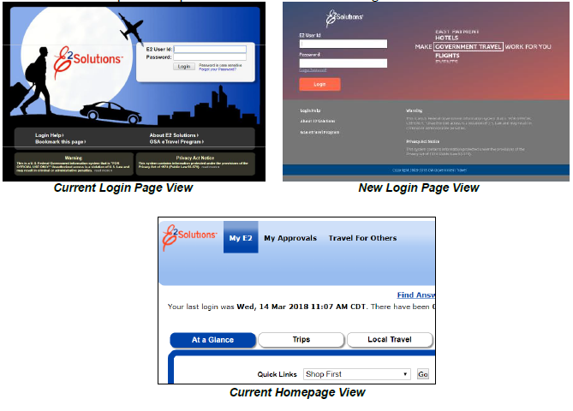

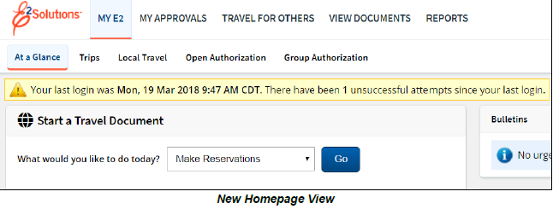

What actions do you need to take?

Continue using E2 as before and enjoy the new design! The FAA Travel Team is updating the E2 User Guides to reflect the UI changes, and these resources will be available on the E2 Online Help / Find Answers page.

21. Edit Traveler Charge Card Information
What is happening and why?

E2 users can edit saved TCC numbers, types, and expiration dates without having to delete and reenter card information in the Edit Credit Card Information section of their profiles. This will make updating new TCC information easier and faster in E2 in cases of lost or expired charge cards.

What will you notice?

The Edit Credit Card Information page, accessed from the User Profile section, has new options to allow users to update or edit TCC information without deleting existing cards or resetting Online Booking Charge Card Default settings.
Review the following steps to update your TCC information.
- Click your Name in the top right corner of the E2 homepage and then Profile.
- On the User Profile page, scroll down and click the Edit Credit Card Information link.
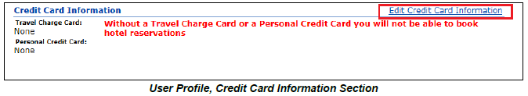
- Modify TCC information in the respective fields.
- Select the Type of Card from the Type of Card drop-down.
- Enter the card number (without spaces or dashes) in the Card Number field.
- Select the card’s expiration date using the Expiration Date drop-down lists.
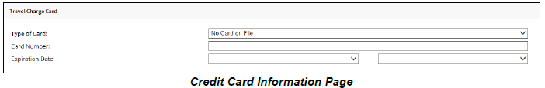
- Click Save Changes at the bottom of the screen to update your user profile. The changes will push to the TMC for future online or agent assisted reservations.
Review the following steps to delete existing credit card information.
- Click the trash can icon ( ).
- The fields will reset and remove the card information from your profile.
- Existing Online Booking Charge Card Defaults for that card are removed and reset to Select One.
- When you enter a new TCC, update the Online Booking Charge Card Defaults section to Traveler Charge Card for the airfare, rail, or hotel guarantee options.

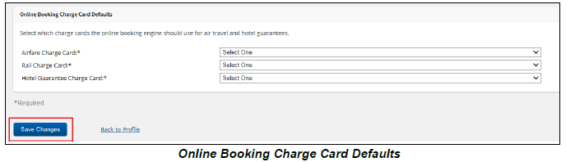
- Click Save Changes when all selections are complete.
What actions do you need to take?

Travelers need to keep their TCC information up to date in their E2 profile to help avoid reservation complications when booking travel in E2. Additionally, travelers should only enter TCC information in E2 to book travel or for travel expenses. Personal charge cards may not be used.

22. New Authorization Amendment Summary View
What is happening and why?

Starting Friday, December 14, 2018, E2 approvers will be able to view a consolidated list of the changes made to amended authorizations. This feature will enable approvers to quickly compare previous versions of authorizations and identify cost differences.

What will you notice?

The Authorization page will have a View Amendment Changes link under the Other Actions section that will open the Amendment Changes Summary window.
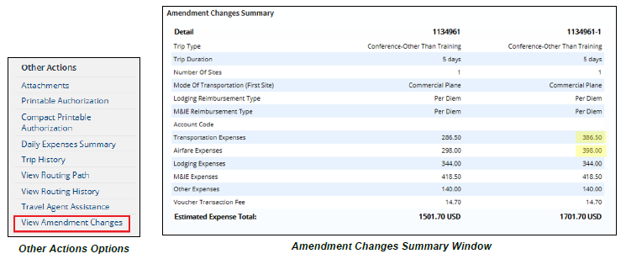

Approvers can compare the following authorization details to identify trip changes:
- Trip Type
- Trip Duration
- Number of Sites
- Mode of Transportation (To First Site)
- Lodging Reimbursement Type
- M&IE Reimbursement Type
- Account Code:
  - Added if the current trip contains an account code not on the previous trip
  - Deleted if the previous trip contains an account code not on the current trip
  - Added/Deleted if both the current and previous trip contain account codes not on the other trip
  - Blank if no account codes were added or deleted
- Transportation Expenses (total of all transportation expenses less any expenses for airfare, airline charge fees, and unused tickets)
- Airfare Expenses (total of all airfare, airline charge fees, and unused tickets expenses)
- Lodging Expenses (total of all lodging fee expenses)
- M&IE Expenses (total of all M&IE expenses)
- Other Expenses (total of all other expenses less any voucher transaction fee expenses)
- Voucher Transaction Fee
- Estimated Expense Total (total of all expenses)
What actions do you need to take?

Follow the steps outlined below to use this feature:
- Click the My Approvals tab, select from the list of travelers’ trips, and click Show.
- On the Trip Dashboard page, identify the most recent authorization document or select a previous authorization document to compare earlier amendments. Click Show to the right of the document details. The Authorization page will appear.
- Click the View Amendment Changes link under Other Actions on the left sidebar. A window will appear listing the differences side-by-side between the authorization selected and previous version.

