## **EBRT Portal Request Form - Guide**

**What is the Employee Banking Request Tool (EBRT)?**

**EBRT is a tool to be used only by employees who wish to use a different bank account for non-payroll payments than they use for their paycheck**. Examples of non-payroll payments are travel reimbursements, professional liability, medical/physical fees, parking, wellness, fuel reimbursement, airport badges, office supplies, internet reimbursements, transit fees, childcare subsidies and EEO claims/settlements. Employees who wish to have such non-payroll payments go to the same bank account as their paycheck should not use this tool.

EBRT Link <https://delphiebrt.esc.gov/EBRT_WebReqApp/requestform>

**\*Payroll bank account changes for payroll deposit must be made within Employees Express at gov** [https://www.employeeexpress.](https://www.employeeexpress.gov) .

**EBRT Portal availability:**

EBRT will be available for updating employee financial information for non-payroll payments from 6:00 AM ET to 9:00 PM ET, Monday through Saturday.

**Portal Form Layout:**

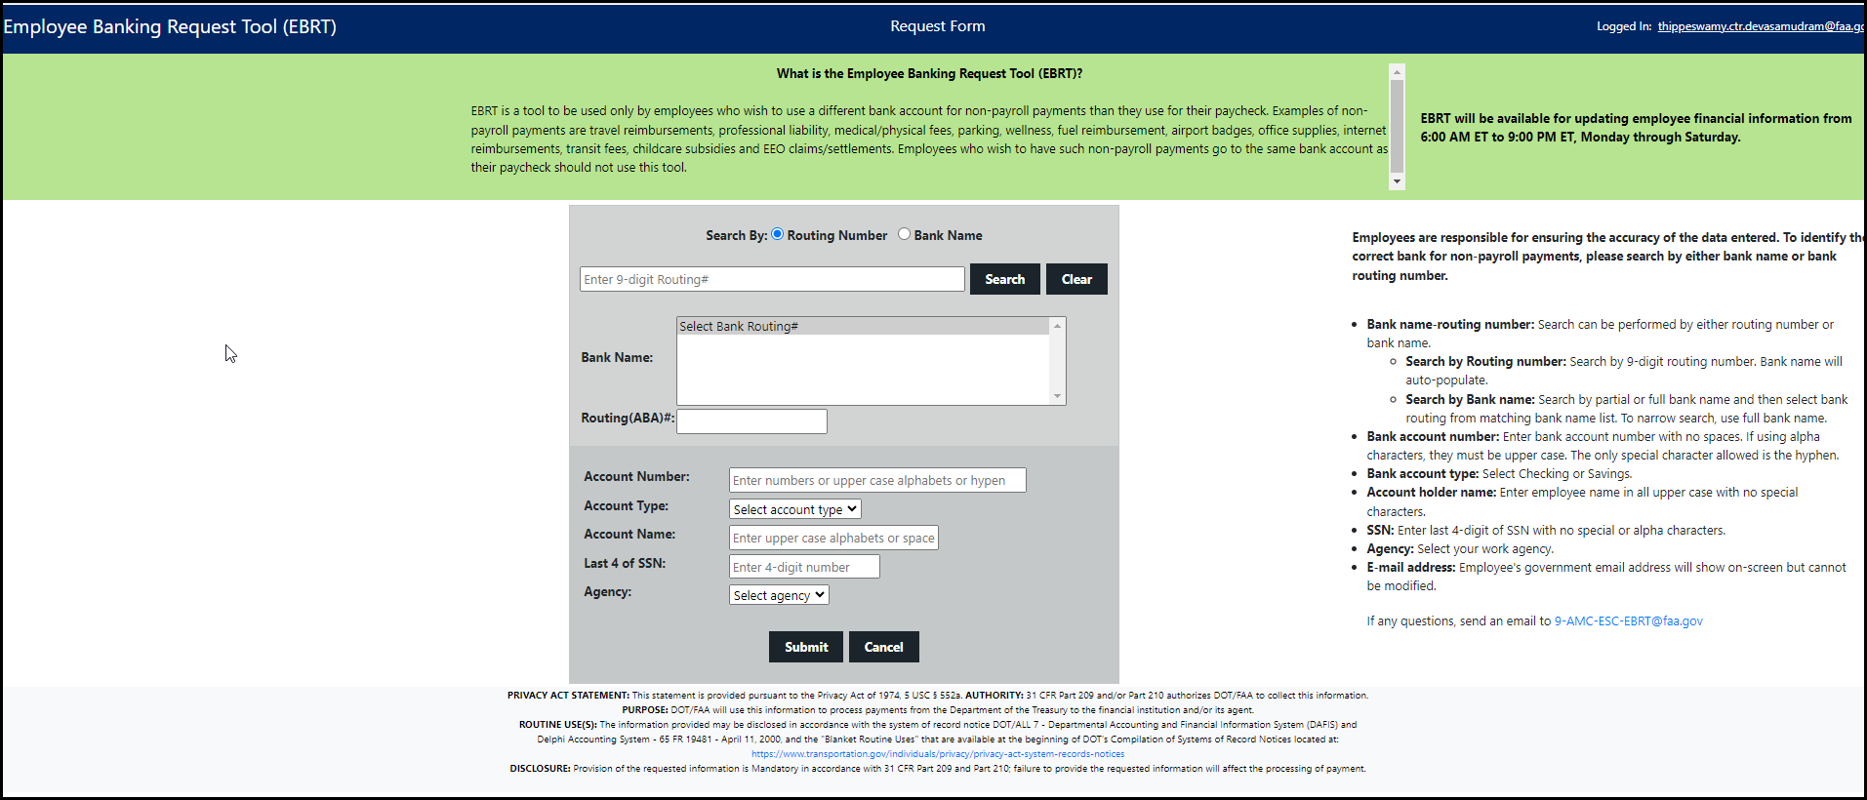

**How to use/fill Request form?**

Employees are responsible for ensuring the accuracy of the data entered. To identify the correct bank for non-payroll payments, please search by either bank name or bank routing number.

**Search by Bank name:** Search by partial or full bank name and then select bank routing from matching bank name list. To narrow search, use full bank name.

**Search by Routing number:** Search by 9-digit routing number. Bank name will auto-populate.

**Bank account number:** Enter bank account number with no spaces. If using alpha characters, they must be upper case. The only special character allowed is the hyphen.

**Bank account type:** Select Checking or Savings.

**Account holder name:** Enter employee name in all upper case with no special characters.

**SSN:** Enter last 4 digits of SSN with no special or alpha characters.

**Agency:** Select your work agency.

**E-mail address:** Employee’s government email address will show on-screen but cannot be modified.

**Processing of EBRT Request:**

Once a request has been successfully submitted, a reference number is generated which could be used in any email communication on the status of the request.

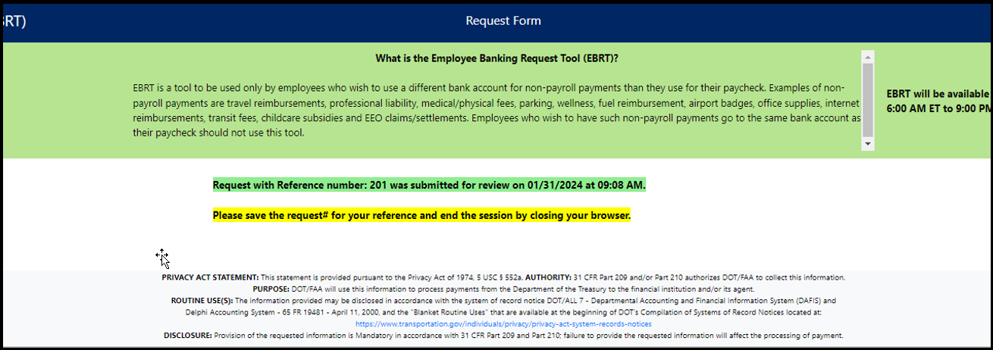

The Enterprise Services Center will review the request, and if all the information provided is validated successfully, will process it in Delphi. An e-mail notification of successful processing of the request is generated and sent to Employee’s government e-mail address.

**Support contact:**

If any questions, send an email to [9-AMC-ESC-EBRT@faa.gov](mailto:9-AMC-ESC-EBRT@faa.gov).

**Footnote:**

**PRIVACY ACT STATEMENT:** This statement is provided pursuant to the Privacy Act of 1974, 5 USC § 552a.

**AUTHORITY:** 31 CFR Part 209 and/or Part 210 authorizes DOT/FAA to collect this information.

**PURPOSE:** This information is used to process non-payroll payments.

**ROUTINE USE(S):** The information provided may be disclosed in accordance with the system of record notice - Delphi Accounting System - 65 FR 19481 - April 11, 2000, and the “Blanket Routine Uses” that are available at the beginning of DOT’s Compilation of Systems of Record Notices located at: <https://www.transportation.gov/individuals/privacy/privacy-act-system-records-notices>

**DISCLOSURE:** Provision of the requested information is Mandatory in accordance with 31 CFR Part 209 and Part 210; failure to provide the requested information will affect the processing of payment.