Enterprise Service Center (ESC)

**E2 Solutions**

**Reservations Toolkit**

Last Updated: May 15, 2018

Table of Contents

1 Introduction 1

1.1 E2 Reservation Overview 1

1.2 Make Reservations (formerly known as Shop First) 1

1.3 Manage Trip Reservations 2

1.4 Refresh Reservation Details 3

2 Reservations 4

2.1 Airfare, Hotel, Rental Car 4

2.2 Airfare and Hotel Only 6

2.3 Airfare Only 8

2.4 Hotel and Rental Car Only 10

2.5 Hotel Only 12

2.6 Rental Car Only 14

2.7 Amtrak 15

2.8 Rail, Hotel, Rental Car 16

2.9 Rail and Hotel Only 18

2.10 Rail Only 20

3 Cancel Reservations 21

4 TDY Lodging Accommodations 23

4.1 FedRooms® 23

4.2 E2 Hotel Display 25

5 State Tax Exemption Information 27

6 Update Travel Charge Card 28

7 Find Answers / Online Help 29

8 ESC eTravel Contact Info 30

9 Travel Management Center (TMC) Contacts 30

10 Fees 30

10.1 TMC Fees 30

10.2 Voucher Fees 30

# 

# 1 Introduction

The E2 Reservation Toolkit is intended to be a helpful tool for government travelers and arrangers, providing virtual assistance for your reservation needs. Use the interactive Table of Contents to quickly jump between sections. (Select View, Navigation to access the navigation toolbar.)

## E2 Reservation Overview

Finding the right flight or train, hotel and rental car to meet your travel requirements is an important part of your travel planning. FAA, DOT (excluding USMMA) and other ESC Customers travel policy supports online booking. Through the E2 OBE (Online Booking Engine) you can:

* Shop for and book reservations before you create and submit your authorization for approval (“Make Reservations”)
* Shop for and book reservations during the actual authorization process

You are free to choose the method that works best for you.

## Make Reservations (formerly known as Shop First)

To get started, choose one of the following:

* Select **Make Reservations** from the Quick Links list on the My E2 **At a Glance** tab, and select **Go**
* Select **Make Reservations** from the My E2 **Trips** tab
* Select the **Make New Reservation** link on the Reservation step after the authorization is created

If you choose to shop for and book reservations during the actual authorization process, you’ll do this after the authorization is created by going to **Step 2: Reservation** within the authorization workflow process.

**TIP**: If you book reservations through “**Make Reservations**” prior to creating an authorization, you’ll have the option to place the reservation(s) in your held reservations queue allowing you to take action later; OR you can create an authorization and complete the approval process. You can also change or cancel the reservation. When reservations are placed in your held reservation queue, a yellow warning message appears on your E2 landing page. This acts as a reminder that action needs to be taken with a user’s booked reservations.

Once reservations are made in E2, further action is required to either:

1. Associate reservations with an authorization and ensure the authorization is approved for airfare tickets to be issued in a timely manner.
2. Ensure unused reservations are cancelled in accordance with the appropriate cancellation policy. Reservations within the Held Reservations queue or those that are associated with an unapproved authorization that contain hotel reservations may incur fees if not cancelled in accordance with the appropriate cancellation policy. (Airfare reservations will auto cancel without an approved authorization 48 hours before the earliest departure. Hotels do not have an automated cancellation policy in place. **Hotel reservations *never* auto cancel.** Once a hotel is booked in E2, it’s just like booking with the hotel directly. When a hotel reservation isn’t cancelled in accordance with the hotel’s cancellation policy, the traveler will be charged penalties and no show fees.)

**TIP**: Access the E2 User Guide (**UG 22**) for step-by-step instructions regarding **Making Reservations** in E2. You must be logged into E2 to access this link.

<https://e2.gov.cwtsatotravel.com/help/ug/ets2_ug22_making_reservations.pdf>

The Reservation step in the authorization workflow shows reservations that are associated with the authorization. It also provides access to online shopping functions and your currently held reservations.

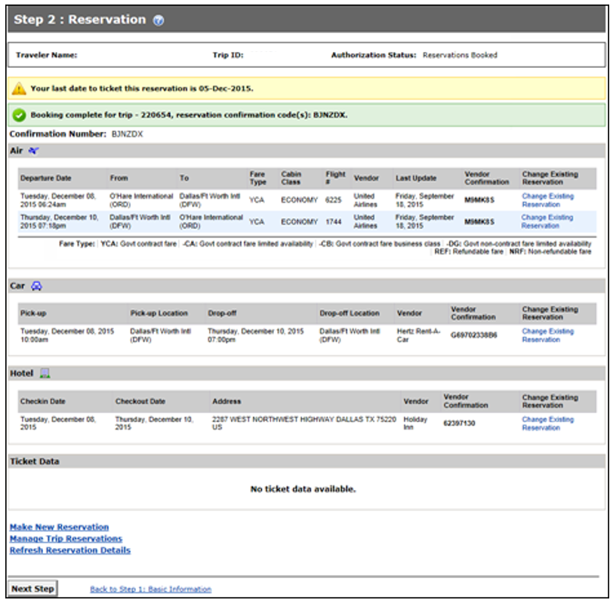

## Manage Trip Reservations

1. Review the reservations currently associated with the trip.
   * If no reservations are displayed on this screen and you wish to make reservations:
     + Select the [Make New Reservation](#_Make_Reservation_(Shop)link to shop online for flights, rail, rental cars and hotels or
     + Click the **Manage Trip Reservations** link to select an existing reservation for this authorization or to enter a confirmation code provided by your travel management center (TMC) and associate that reservation with your authorization. (*Additional assistance for the Manage Trip Reservations window can be found by selecting the link above or through the E2 Find Answers Knowledge Portal -* *Help for authorization Manage Trip Reservations window* *Answer ID: 3980*).
   * If you need to change an existing reservation that you made online, select the Change Existing Reservation link for the item you want to change. This link may not always be available and depends on the status of the authorization and the status of the reservation. For example, you cannot make changes to a reservation that is awaiting agent action (agent intervention).

**TIP**: You cannot make online changes to rail reservations or reservations made for you by your travel agent (TMC). Select the **Travel Agent Assistance** link in the OTHER ACTIONS section (on the left side of the page) to request rail reservation changes or changes to any reservation made for you by the TMC or contact Amtrak directly.

* + To remove an existing reservation from an authorization, select the **Manage Trip Reservations** link. Within the **Manage Trip Reservations** section, you’re able to move reservations to your Held Reservation list or Cancel reservations. Moving reservations to the Held Reservation list will not cancel the reservation. If the reservation should be cancelled, it’s imperative that you select Cancel reservations to ensure no additional penalties or fees are incurred.



1. Select **Next Step** to move to the next step within the authorization workflow process.

**Alternate Action:**

* If no reservations are associated with the authorization and you want to skip the reservation process, select **Next Step** to continue.
* If you have no actions available to you, select **Next Step** to continue.

**TIP**: Once reservations are made in E2, further action is required to either:

1. Associate reservations with an authorization and ensure the authorization is approved for airfare tickets to be issued in a timely manner.
2. Ensure unused reservations are cancelled. Reservations in the Held Reservations list or those that are associated with an unapproved authorization that contain hotel reservations may incur fees if not cancelled in accordance with the hotel’s cancellation policy. (Airfare reservations will auto cancel without an approved authorization 48 hours before the earliest departure. Hotels do not have an automated cancellation policy in place. **Hotel reservations *never* auto cancel.** Once a hotel is booked in E2, it’s just like booking with the hotel directly. When a hotel reservation isn’t cancelled in accordance with the hotel’s cancellation policy, the traveler will be charged.)

## Refresh Reservation Details

The two most common instances when you’d use Refresh Reservations details would be

* + If you have an existing reservation associated with the trip and changes have been made to that reservation, select the Refresh Reservation Details link to retrieve the updated reservation details. This link is available if you are allowed to make changes to the document. It is not available if the document is pending approval or if it is in an agent intervention status.
  + If the airfare reservations did not price, you can go back into the document after 1 - 4 hours, select **Refresh Reservation Details** and the Airfare amount under the Expenses section should be displayed. Do not submit authorizations for approval that contain airfare expenses that display $0.00.
  + To remove an existing reservation from an authorization, click the Manage Trip Reservations link.

**TIP**: The Last Update column shows the last time you made a change to the reservation via the Change Existing Reservation link, or selected the Refresh Reservation Details link.

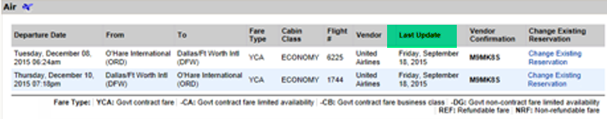

# Reservations

## Airfare, Hotel, Rental Car

When airfare, hotel, and rental car reservations are made in E2 or directly with the TMC, additional action is required.

* If the reservations will be used, they must be associated with an approved authorization before tickets can be issued. The **TMC fee** will be charged when the tickets are issued. This fee is non-refundable and should be claimed on a voucher for reimbursement. (See Manage Trip Reservation section for additional information regarding how to associate reservations with an authorization.)
  + If the reservations are booked, but the **document remains unapproved**, the document needs to be approved 3 business days prior to the Trip Start Date.
  + In October 2012, airlines implemented an auto-cancellation policy. Reservations that aren’t associated with an approved authorization will be auto-cancelled by the airline, 48 hours prior to the earliest departure date. To help ensure reservations are ticketed in a timely manner, authorizations should be approved 3 business days prior to the earliest departure date. ***If your reservations fall under this scenario, please note that the 48 hour cancellation rule only applies to air reservations.***
* If the reservations are no longer needed, they should be cancelled whether they’re in a travelers Held Reservation queue, in an unapproved authorization or an approved authorization. (See Cancel Trip instructions for assistance with cancelling an E2 authorization with reservations.)
  + If the reservations are booked and appear on the Reservation step within the authorization, but the **document remains unapproved**, the document needs to be cancelled in accordance with the hotel cancellation policy **to avoid penalties and no show fees**. Depending on the room rate that was booked, the cancellation timeframe may vary from 4pm the day of travel to 72 hours prior to check-in.
  + If the reservations are booked and appear in the traveler’s **Held Reservation** queue, but not associated with an authorization, the reservation needs to be cancelled in accordance with the hotel cancellation policy. Depending on the room rate that was booked, this timeframe may vary from 4pm the day of travel to 72 hours prior to check-in. The **TMC fee** for this scenario is charged on the Trip Start Date. This fee is non-refundable and should be claimed on a voucher for reimbursement.
  + If the **authorization is approved**, and reservations no longer needed, the reservations will need to be cancelled in accordance with the hotel cancellation policy.
    - Depending on the room rate that was booked, the cancellation timeframe may vary from 4pm the day of travel to 72 hours prior to check-in. The **TMC fee** for this scenario was charged when the authorization received final approval. This fee is non-refundable and should be claimed on a voucher for reimbursement.
      * Hotels do not have an automated cancellation policy in place. **Hotel reservations *never* auto cancel.** Once a hotel is booked in E2, it’s just like booking with the hotel directly. When a hotel reservation isn’t cancelled in accordance with the hotel’s cancellation policy, the traveler will be charged penalties and no show fees. **Travelers are responsible for ensuring reservations are cancelled in accordance with the hotels cancellation policy. Check itinerary to confirm hotel cancellation policy.**
* Reservations can be changed in E2 up to 4 business days prior to the earliest departure date, before tickets are issued.
  + Go to Trip Dashboard to see if tickets have been issued.

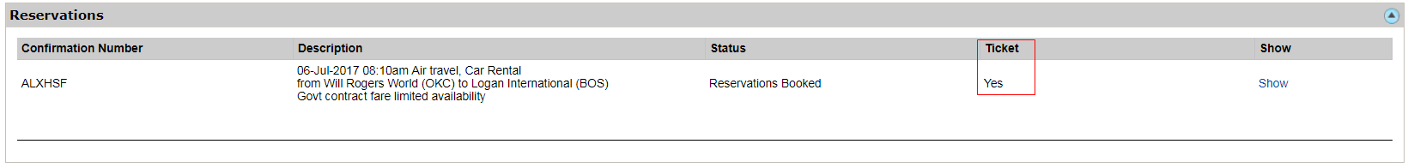

* If a change needs to be made to the itinerary (i.e. leaving early, leaving later) and tickets have already been issued, call the respective TMC to make the change. TMC Contact Info
* The reservations can be cancelled in E2 before or after the tickets have been issued.
* The traveler may also call the TMC to ensure reservations are cancelled. Once reservations are cancelled, either in E2 by the user or by calling the TMC directly, the reservation will be processed for a refund and a refund notification will be sent out advising the traveler the refund was processed and the amount refunded.
* The **TMC fee(s)** will be charged when airfare is ticketed. This fee is non-refundable and should be claimed on a voucher for reimbursement. **If a non-refundable fare was booked and not cancelled prior to scheduled departure, the ticket will have no residual value. If cancelled prior to departure, check with the TMC on penalties and reuse of the ticket for future official travel.** (See Cancel Trip Instructions for assistance with cancelling an E2 authorization with reservations.)
  + Reservations cancelled prior to ticketing will not incur a TMC fee.
  + If the TMC is contacted and changes are made to reservations after ticketing, a **TMC fee** will be incurred each time the agent makes a change to a reservation.

## Airfare and Hotel Only

When airfare and hotel reservations are made in E2 or directly with the TMC, additional action is required.

* If the reservations will be used, they must be associated with an approved authorization before tickets can be issued. The **TMC fee** will be charged when the tickets are issued. This fee is non-refundable and should be claimed on a voucher for reimbursement. (See Manage Trip Reservation section for additional information regarding how to associate reservations with an authorization.)
  + If the reservations are booked, but the **document remains unapproved**, the document needs to be approved 3 business days prior to the Trip Start Date.
  + In October 2012, the airlines implemented an auto-cancellation policy. Reservations that aren’t associated with an approved authorization will be auto-cancelled by the airline, 48 hours prior to the earliest departure date. To help ensure reservations are ticketed in a timely manner, authorizations should be approved 3 business days prior to the earliest departure date. ***If your reservations fall under this scenario, please note that the 48 hour cancellation rule only applies to air reservations.***
* If the reservations are no longer needed, they should be cancelled whether they’re in a travelers Held Reservation queue, in an unapproved authorization or an approved authorization. (See Cancel Trip instructions for assistance with cancelling an E2 authorization with reservations.)
  + If the reservations are booked and appear on the Reservation step within the authorization, but the **document remains unapproved**, the document needs to be cancelled in accordance with the hotel cancellation policy **to avoid penalties and no show fees**. Depending on the room rate that was booked, the cancellation timeframe may vary from 4pm the day of travel to 72 hours prior to check-in.
  + If the reservations are booked and appear in the traveler’s **Held Reservation** queue, but not associated with an authorization, the reservation needs to be cancelled in accordance with the hotel cancellation policy. Depending on the room rate that was booked, this timeframe may vary from 4pm the day of travel to 72 hours prior to check-in. The **TMC fee** for this scenario is charged on the Trip Start Date. This fee is non-refundable and should be claimed on a voucher for reimbursement.
  + If the **authorization is approved**, and reservations no longer needed, the reservations will need to be cancelled in accordance with the hotel cancellation policy.
    - Depending on the room rate that was booked, the cancellation timeframe may vary from 4pm the day of travel to 72 hours prior to check-in. The **TMC fee** for this scenario was charged when the authorization received final approval. This fee is non-refundable and should be claimed on a voucher for reimbursement.
      * Hotels do not have an automated cancellation policy in place. **Hotel reservations *never* auto cancel.** Once a hotel is booked in E2, it’s just like booking with the hotel directly. When a hotel reservation isn’t cancelled in accordance with the hotel’s cancellation policy, the traveler will be charged penalties and no show fees. **Travelers are responsible for ensuring reservations are cancelled in accordance with the hotels cancellation policy. Check itinerary to confirm hotel cancellation policy.**
* Reservations can be changed in E2 up to 4 business days prior to the earliest departure date, before tickets are issued.
  + Go to Trip Dashboard to see if tickets have been issued.



* If a change needs to be made to the itinerary (i.e. leaving early, leaving later) and tickets have already been issued, call the respective TMC to make the change. TMC Contact Info
* The reservations can be cancelled in E2 before or after the tickets have been issued.
* The traveler may also call the TMC to ensure reservations are cancelled. Once reservations are cancelled, either in E2 by the user or by calling the TMC directly, the reservation will be processed for a refund and a refund notification will be sent out advising the traveler the refund was processed and the amount refunded.
* The **TMC fee(s)** will be charged when airfare is ticketed. This fee is non-refundable and should be claimed on a voucher for reimbursement. **If a non-refundable fare was booked and not cancelled prior to scheduled departure, the ticket will have no residual value. If cancelled prior to departure, check with the TMC on penalties and reuse of the ticket for future official travel.** (See Cancel Trip Instructions for assistance with cancelling an E2 authorization with reservations.)
  + Reservations cancelled prior to ticketing will not incur a TMC fee.
  + If the TMC is contacted and changes are made to reservations after ticketing, a **TMC fee** will be incurred each time the agent makes a change to a reservation.

## Airfare Only



When airfare only reservations are made in E2 or directly with the TMC, additional action is required.

* If the reservations will be used, they must be associated with an approved authorization before tickets can be issued. The **TMC fee** will be charged when the tickets are issued. This fee is non-refundable and should be claimed on a voucher for reimbursement. (See Manage Trip Reservation section for additional information regarding how to associate reservations with an authorization.)
  + If the reservations are booked, but the **document remains unapproved**, the document needs to be approved 3 business days prior to the Trip Start Date.
  + In October 2012, airlines implemented an auto-cancellation policy. Reservations that aren’t associated with an approved authorization will be auto-cancelled by the airline, 48 hours prior to the earliest departure date. To help ensure reservations are ticketed in a timely manner, authorizations should be approved 3 business days prior to the earliest departure date. ***If your reservations fall under this scenario, please note that the 48 hour cancellation rule only applies to air reservations.***
* If the reservations are no longer needed, they should be cancelled whether they’re in a travelers Held Reservation queue, in an unapproved authorization or an approved authorization. (See Cancel Trip instructions for assistance with cancelling an E2 authorization with reservations.)
  + If the reservations are booked and appear on the Reservation step within the authorization, but the **document remains unapproved**, the document needs to be cancelled in E2.
  + If the reservations are booked and appear in the traveler’s **Held Reservation** queue, but not associated with an authorization, the reservation needs to be cancelled in accordance with the hotel cancellation policy. Depending on the room rate that was booked, this timeframe may vary from 4pm the day of travel to 72 hours prior to check-in. The **TMC fee** for this scenario is charged on the Trip Start Date. This fee is non-refundable and should be claimed on a voucher for reimbursement.
  + If the **authorization is approved**, and reservations no longer needed, the reservations will need to be cancelled in accordance with the hotel cancellation policy.
* Reservations can be changed in E2 up to 4 business days prior to the earliest departure date, before tickets are issued.
  + Go to Trip Dashboard to see if tickets have been issued.



* If a change needs to be made to the itinerary (i.e. leaving early, leaving later) and tickets have already been issued, call the respective TMC to make the change. TMC Contact Info
* The reservations can be cancelled in E2 before or after the tickets have been issued.
* The traveler may also call the TMC to ensure reservations are cancelled. Once reservations are cancelled, either in E2 by the user or by calling the TMC directly, the reservation will be processed for a refund and a refund notification will be sent out advising the traveler the refund was processed and the amount refunded.
* The **TMC fee(s)** will be charged when airfare is ticketed. This fee is non-refundable and should be claimed on a voucher for reimbursement. **If a non-refundable fare was booked and not cancelled prior to scheduled departure, the ticket will have no residual value. If cancelled prior to departure, check with the TMC on penalties and reuse of the ticket for future official travel.** (See Cancel Trip Instructions for assistance with cancelling an E2 authorization with reservations.)
  + Reservations cancelled prior to ticketing will not incur a TMC fee.
  + If the TMC is contacted and changes are made to reservations after ticketing, a **TMC fee** will be incurred each time the agent makes a change to a reservation.

## Hotel and Rental Car Only

When hotel and rental car only reservations are made in E2 or directly with the TMC, additional action is required.

* If the reservations will be used, they must be associated with an approved authorization. The **TMC fee** will be charged when the authorization receives final approval. This fee is non-refundable and should be claimed on a voucher for reimbursement. (See Manage Trip Reservation section for additional information regarding how to associate reservations with an authorization.)
  + If the reservations are booked, but the **document remains unapproved**, the document needs to be approved 3 business days prior to the Trip Start Date.
* If the reservations are no longer needed, they should be cancelled whether they’re in a travelers Held Reservation queue, in an unapproved authorization or an approved authorization. (See Cancel Trip instructions for assistance with cancelling an E2 authorization with reservations.)
  + If the reservations are booked and appear on the Reservation step within the authorization, but the **document remains unapproved**, the document needs to be cancelled in accordance with the hotel and rental car cancellation policy to avoid penalties and no show fees. Depending on the room rate that was booked, the cancellation timeframe may vary from 4pm the day of travel to 72 hours prior to check-in.
  + If the reservations are booked and appear in the traveler’s **Held Reservation** queue, but not associated with an authorization, the reservation needs to be cancelled in accordance with the hotel and rental car cancellation policy.
    - Depending on the room rate that was booked, this timeframe may vary from 4pm the day of check-in to 72 hours prior to check-in. The **TMC fee** for this scenario is charged on the Trip Start Date. This fee is non-refundable and should be claimed on a voucher for reimbursement.
  + If the **authorization is approved**, and reservations no longer needed, the reservations will need to be cancelled in accordance with the hotel cancellation policy.
    - Depending on the room rate that was booked, this timeframe may vary from 4pm the day of check-in to 72 hours prior to check-in. The **TMC fee** for this scenario was charged when the authorization received final approval. This fee is non-refundable and should be claimed on a voucher for reimbursement.
      * Hotels do not have an automated cancellation policy in place. **Hotel reservations *never* auto cancel.** Once a hotel is booked in E2, it’s just like booking with the hotel directly. When a hotel reservation isn’t cancelled in accordance with the hotel’s cancellation policy, the traveler will be charged penalties and no show fees. **Travelers are responsible for ensuring reservations are cancelled in accordance with the hotels cancellation policy. Check itinerary to confirm hotel cancellation policy.**
* The authorization and reservations can be cancelled in E2 through the Cancel Trip link located on the Trip Dashboard. If the Cancel Trip link is not available, see the Cancel Trip Instructions for assistance with cancelling an E2 authorization with reservations. **Travelers are responsible for ensuring they’re cancelling reservations in accordance with the hotel and/or rental car company cancellation policy. Check itinerary to confirm hotel/rental car cancellation policy.**
  + If cancellation is being processed after the cancellation policy timeframe, travelers may incur penalties and no show fees. Typical fees include first night’s stay + taxes. The lodging can be claimed on a voucher for reimbursement. (See Cancel Trip Instructions for assistance with cancelling an E2 authorization with reservations.)
* Depending on cancellation policy for the room rate booked, reservations can be changed in E2 up to 3 business days prior to the earliest departure date. FedRoom rates are the suggested room rate for government travelers. These have more lenient cancellation policies as well as other amenities offered to government travelers. See FedRoom First Initiative for additional details.
* Reservations cancelled within the appropriate timeframe will not incur a TMC fee.

**HINT**: If a hotel only reservation is never approved nor cancelled, the **TMC fee** will be charged on day of check- in.(See Cancel Trip Instructions for assistance with cancelling an E2 authorization with reservations.) This fee is non-refundable and should be claimed on a voucher for reimbursement.

## Hotel Only

When hotel only reservations are made in E2 or directly with the TMC, additional action is required.

* If the reservations will be used, they must be associated with an approved authorization. The **TMC fee** will be charged when the authorization receives final approval. This fee is non-refundable and should be claimed on a voucher for reimbursement. (See Manage Trip Reservation section for additional information regarding how to associate reservations with an authorization.)
  + If the reservations are booked, but the **document remains unapproved**, the document needs to be approved 3 business days prior to the Trip Start Date.
* If the reservations are no longer needed, they should be cancelled whether they’re in a travelers Held Reservation queue, in an unapproved authorization or an approved authorization. (See Cancel Trip instructions for assistance with cancelling an E2 authorization with reservations.)
  + If the reservations are booked and appear on the Reservation step within the authorization, but the **document remains unapproved**, the document needs to be cancelled in accordance with the hotel cancellation policy to avoid penalties and no show fees. Depending on the room rate that was booked, the cancellation timeframe may vary from 4pm the day of travel to 72 hours prior to check-in.
  + If the reservations are booked and appear in the traveler’s **Held Reservation** queue, but not associated with an authorization, the reservation needs to be cancelled in accordance with the hotel cancellation policy. Depending on the room rate that was booked, this timeframe may vary from 4pm the day of travel to 72 hours prior to check-in. The **TMC fee** for this scenario is charged on the Trip Start Date. This fee is non-refundable and should be claimed on a voucher for reimbursement.
  + If the **authorization is approved**, and reservations no longer needed, the reservations will need to be cancelled in accordance with the hotel cancellation policy.
    - Depending on the room rate that was booked, the cancellation timeframe may vary from 4pm the day of travel to 72 hours prior to check-in. The **TMC fee** for this scenario was charged when the authorization received final approval. This fee is non-refundable and should be claimed on a voucher for reimbursement.
      * Hotels do not have an automated cancellation policy in place. **Hotel reservations *never* auto cancel.** Once a hotel is booked in E2, it’s just like booking with the hotel directly. When a hotel reservation isn’t cancelled in accordance with the hotel’s cancellation policy, the traveler will be charged penalties and no show fees. **Travelers are responsible for ensuring reservations are cancelled in accordance with the hotels cancellation policy. Check itinerary to confirm hotel cancellation policy.**
* The authorization and reservations can be cancelled in E2 through the Cancel Trip link located on the Trip Dashboard. If the Cancel Trip link is not available, see the Cancel Trip Instructions for assistance with cancelling an E2 authorization with reservations. **Travelers are responsible for ensuring they’re cancelling reservations in accordance with the hotel cancellation policy. Check itinerary to confirm hotel cancellation policy.**
  + If cancellation is being processed after the cancellation policy timeframe, travelers may incur penalties and no show fees. Typical fees include first night’s stay + taxes. If approved by management, the lodging can be claimed on a voucher for reimbursement. (See Cancel Trip Instructions for assistance with cancelling an E2 authorization with reservations.)
* Depending on cancellation policy for the room rate booked, reservations can be changed in E2 up to 3 business days prior to the earliest departure date. FedRoom rates are the suggested room rate for government travelers. These have more lenient cancellation policies as well as other amenities offered to government travelers. See FedRoom First Initiative for additional details.
* Reservations cancelled within the appropriate timeframe will not incur a TMC fee.

**HINT**: If a hotel only reservation is never approved nor cancelled, the **TMC fee** will be charged on day of check- in.(See Cancel Trip Instructions for assistance with cancelling an E2 authorization with reservations.) This fee is non-refundable and should be claimed on a voucher for reimbursement.

## Rental Car Only

When rental car only reservations are made in E2, additional action is required.

* If the reservations will be used, they must be associated with an approved authorization. The **TMC fee** will be charged when the authorization receives final approval. This fee is non-refundable and should be claimed on a voucher for reimbursement. (See Manage Trip Reservation section for additional information regarding how to associate reservations with an authorization.)
  + If the reservations are booked, but the **document remains unapproved**, the document needs to be approved 3 business days prior to the Trip Start Date.
* If the reservations are no longer needed, they should be cancelled whether they’re in a travelers Held Reservation queue, in an unapproved authorization or an approved authorization. (See Cancel Trip instructions for assistance with cancelling an E2 authorization with reservations.)
  + If the reservations are booked and appear on the Reservation step within the authorization, but the **document remains unapproved**, the document needs to be cancelled in accordance with the rental car cancellation policy.
  + If the reservations are booked and appear in the traveler’s Held Reservation queue, and aren’t associated with an authorization, the reservation needs to be cancelled prior to the Trip Start Date.
  + If the **authorization is approved**, and reservations no longer needed, the reservations will need to be cancelled in accordance with the rental car cancellation policy. The **TMC fee** for this scenario was charged when the authorization received final approval. This fee is non-refundable and should be claimed on a voucher for reimbursement.
    - **Making reservations through E2 is similar to making reservations with the rental car company directly. Travelers are responsible for ensuring reservations are cancelled or additional fees may be incurred. Check itinerary to confirm rental car cancellation policy.**
* The authorization and reservations can be cancelled in E2 through the Cancel Trip link located on the Trip Dashboard. If the Cancel Trip link is not available, see the Cancel Trip Instructions for assistance with cancelling an E2 authorization with reservations. **Travelers are responsible for ensuring they’re cancelling reservations in accordance with the rental car company cancellation policy. Check itinerary to confirm rental car cancellation policy.**
  + If cancellation is being processed after the cancellation policy timeframe, travelers may incur penalties and no show fees. If approved by management, the lodging can be claimed on a voucher for reimbursement. (See Cancel Trip Instructions for assistance with cancelling an E2 authorization with reservations.)
* Depending on cancellation policy, reservations can be changed in E2 up to 3 business days prior to the earliest departure date.

**HINT**: If a rental car only reservation is never approved nor cancelled, the **TMC fee** will be charged on pick-up.(See Cancel Trip Instructions for assistance with cancelling an E2 authorization with reservations.) This fee is non-refundable and should be claimed on a voucher for reimbursement.

## Amtrak

Recent changes made to Amtrak’s federal program are a huge benefit to our government travelers.

* Acela fares that are booked and ticketed using a traveler’s IBA (government issued credit card) are fully refundable if canceled prior to departure – no refund fees
* Northeast Regional fares that are booked and ticketed using a traveler’s IBA (government issued credit card) are fully refundable if canceled prior to departure – no refund fees
* No-show/no-cancel are subject to forfeiture – no change to this requirement

These changes eliminate the 20% refund penalty when reservations are cancelled within 48 hours of departure that federal travelers were paying.

Federal discount pricing on Amtrak and eliminating the refund penalty for trips canceled within 48 hours are available only on reservations booked through E2 Solutions / GetThere or the TMC, not via Amtrak directly. (**NOTE**: You must still cancel your reservation prior to departure or the ticket will NOT be refundable. This requirement has not changed; Amtrak requires that a trip be canceled prior to departure to be refundable. Reservations can be canceled directly with Amtrak, the TMC, or via E2 Solutions.)

For more information and program details, reference Amtrak’s website:

<https://www.amtrak.com/government-discount>

These details are shown on every rail itinerary that is issued by the TMC.

********** NEW AMTRAK REFUND POLICY **************

ALL TICKETED COACH CLASS, ACELA EXPRESS RESERVATIONS

MUST BE CANCELLED AT LEAST 48 HOURS PRIOR TO THE

TRAINS SCHEDULED DEPARTURE TIME IN ORDER TO BE

ELIGIBLE FOR A FULL REFUND. IF THE RESERVATION IS

CANCELLED WITHIN 48 HOURS OF THE SCHEDULED DEPARTURE

A REFUND FEE WILL APPLY.

*** IF THE RESERVATION IS NOT CANCELED PRIOR TO THE

SCHEDULED DEPARTURE ** NO SHOW ** THE ENTIRE AMOUNT

PAID FOR THE RESERVATION WILL BE NON REFUNDABLE ***

## Rail, Hotel, Rental Car

When rail, hotel and rental car only reservations are made in E2, additional action is required.

* If the reservations will be used, they must be associated with an approved authorization. The **TMC fee** will be charged when rail tickets are issued. This fee is non-refundable and should be claimed on a voucher for reimbursement. (See Manage Trip Reservation section for additional information regarding how to associate reservations with an authorization.)
  + If the reservations are booked, but the **document remains unapproved**, the document needs to be approved 3 business days prior to the Trip Start Date.
* If the reservations are no longer needed, they should be cancelled whether they’re in a travelers Held Reservation queue, in an unapproved authorization or an approved authorization. (See Cancel Trip instructions for assistance with cancelling an E2 authorization with reservations.)
  + If the reservations are booked and appear on the Reservation step within the authorization, but the **document remains unapproved**, the document needs to be cancelled in accordance with Amtrak’s cancellation policy.
  + If the reservations are booked and appear in the traveler’s Held Reservation queue, and aren’t associated with an authorization, the reservation needs to be cancelled in accordance with Amtrak, the hotel and rental car company’s cancellation policy.
    - If rail reservations are not cancelled 48 hours prior to the scheduled departure, fare is subject to forfeit and possibly no refund. (See Cancel Trip Instructions for assistance with cancelling an E2 authorization with reservations.)
    - Depending on the room rate that was booked, this timeframe may vary from 4pm the day of travel to 72 hours prior to check-in. The **TMC fee** for this scenario is charged on the Trip Start Date. This fee is non-refundable and should be claimed on a voucher for reimbursement.
  + If the **authorization is approved**, and reservations no longer needed, the reservations will need to be cancelled in accordance with Amtrak, the hotel and rental car company’s cancellation policy.
    - If rail reservations are not cancelled 48 hours prior to the scheduled departure, fare is subject to forfeit and possibly no refund. (See Cancel Trip Instructions for assistance with cancelling an E2 authorization with reservations.)
    - Depending on the room rate that was booked, this timeframe may vary from 4pm the day of check-in to 72 hours prior to check-in. The **TMC fee** for this scenario was charged when the authorization received final approval. This fee is non-refundable and should be claimed on a voucher for reimbursement.
      * Hotels do not have an automated cancellation policy in place. **Hotel reservations *never* auto cancel.** Once rail/hotel/rental car reservations are booked in E2, it’s similar to booking with the chains directly. When these reservations aren’t cancelled in accordance with the cancellation policies, travelers risk forfeiting rail refunds as well as being charged penalties and no show fees from the hotel. **Travelers are responsible for ensuring reservations are cancelled in accordance with the cancellation policies. Check itinerary to confirm cancellation policies.**
* The authorization and reservations can be cancelled in E2 through the Cancel Trip link located on the Trip Dashboard. If the Cancel Trip link is not available, see the Cancel Trip Instructions for assistance with cancelling an E2 authorization with reservations. **Travelers are responsible for ensuring they’re cancelling reservations in accordance with the rail and rental car company cancellation policy. Check itinerary to confirm rail and rental car cancellation policy.**
* If a change needs to be made to the itinerary (i.e. leaving early, leaving later, or cancel reservations) and tickets have already been issued, call the respective TMC to make the change. TMC Contact Info
* Depending on cancellation policy, reservations can be changed in E2 up to 3 business days prior to the earliest departure date.

## Rail and Hotel Only

When rail and hotel reservations are made in E2, additional action is required.

* If the reservations will be used, they must be associated with an approved authorization. The **TMC fee** will be charged when rail tickets are issued. This fee is non-refundable and should be claimed on a voucher for reimbursement. (See Manage Trip Reservation section for additional information regarding how to associate reservations with an authorization.)
  + If the reservations are booked, but the **document remains unapproved**, the document needs to be approved 3 business days prior to the Trip Start Date.
* If the reservations are no longer needed, they should be cancelled whether they’re in a travelers Held Reservation queue, in an unapproved authorization or an approved authorization. (See Cancel Trip instructions for assistance with cancelling an E2 authorization with reservations.)
  + If the reservations are booked and appear on the Reservation step within the authorization, but the **document remains unapproved**, the document needs to be cancelled in accordance with Amtrak and the hotel’s cancellation policy.
  + If the reservations are booked and appear in the traveler’s Held Reservation queue, and aren’t associated with an authorization, the reservation needs to be cancelled in accordance with Amtrak and the hotel’s cancellation policy.
    - If rail reservations are not cancelled 48 hours prior to the scheduled departure, fare is subject to forfeit and possibly no refund. (See Cancel Trip Instructions for assistance with cancelling an E2 authorization with reservations.)
    - Depending on the room rate that was booked, this timeframe may vary from 4pm the day of travel to 72 hours prior to check-in. The **TMC fee** for this scenario is charged on the Trip Start Date. This fee is non-refundable and should be claimed on a voucher for reimbursement.
  + If the **authorization is approved**, and reservations no longer needed, the reservations will need to be cancelled in accordance with Amtrak and the hotel’s cancellation policy.
    - If rail reservations are not cancelled 48 hours prior to the scheduled departure, fare is subject to forfeit and possibly no refund. (See Cancel Trip Instructions for assistance with cancelling an E2 authorization with reservations.)
    - Depending on the room rate that was booked, this timeframe may vary from 4pm the day of check-in to 72 hours prior to check-in. The **TMC fee** for this scenario was charged when the authorization received final approval. This fee is non-refundable and should be claimed on a voucher for reimbursement.
      * Hotels do not have an automated cancellation policy in place. **Hotel reservations *never* auto cancel.** Once rail/hotel reservations are booked in E2, it’s similar to booking with the chains directly. When these reservations aren’t cancelled in accordance with the cancellation policies, travelers risk forfeiting rail refunds as well as being charged penalties and no show fees from the hotel. **Travelers are responsible for ensuring reservations are cancelled in accordance with the cancellation policies. Check itinerary to confirm cancellation policies.**
* The authorization and reservations can be cancelled in E2 through the Cancel Trip link located on the Trip Dashboard. If the Cancel Trip link is not available, see the Cancel Trip Instructions for assistance with cancelling an E2 authorization with reservations. **Travelers are responsible for ensuring they’re cancelling reservations in accordance with the Amtrak and hotel cancellation policy. Check itinerary to confirm Amtrak and hotel cancellation policy.**
* If a traveler needs to cancel reservations after rail tickets are issued, traveler must call the TMC to ensure cancellation is processed and refunds are issued when applicable.
* Depending on cancellation policy, reservations can be changed in E2 up to 3 business days prior to the earliest departure date.

## Rail Only

When rail only reservations are made in E2, additional action is required.

* If the reservations will be used, they must be associated with an approved authorization. The **TMC fee** will be charged when rail tickets are issued. This fee is non-refundable and should be claimed on a voucher for reimbursement. (See Manage Trip Reservation section for additional information regarding how to associate reservations with an authorization.)
  + If the reservations are booked, but the **document remains unapproved**, the document needs to be approved 3 business days prior to the Trip Start Date.
* If the reservations are no longer needed, they should be cancelled whether they’re in a travelers Held Reservation queue, in an unapproved authorization or an approved authorization. (See Cancel Trip instructions for assistance with cancelling an E2 authorization with reservations.)
  + If the reservations are booked and appear on the Reservation step within the authorization, but the **document remains unapproved**, the document needs to be cancelled in accordance with Amtrak cancellation policy.
  + If the reservations are booked and appear in the traveler’s Held Reservation queue, and aren’t associated with an authorization, the reservation needs to be cancelled in accordance with Amtrak’s cancellation policy.
    - If rail reservations are not cancelled 48 hours prior to the scheduled departure, fare is subject to forfeit and possibly no refund. (See Cancel Trip Instructions for assistance with cancelling an E2 authorization with reservations.)
  + If the **authorization is approved**, and reservations no longer needed, the reservations will need to be cancelled in accordance with Amtrak’s cancellation policy.
    - If rail reservations are not cancelled 48 hours prior to the scheduled departure, fare is subject to forfeit and possibly no refund. (See Cancel Trip Instructions for assistance with cancelling an E2 authorization with reservations.)
      * Making reservations through E2 is similar to making reservations with the Amtrak directly. **Travelers are responsible for ensuring reservations are cancelled or additional fees will be incurred. Check itinerary to confirm Amtrak’s cancellation policy.**
* The authorization and reservations can be cancelled in E2 through the Cancel Trip link located on the Trip Dashboard. If the Cancel Trip link is not available, see the Cancel Trip Instructions for assistance with cancelling an E2 authorization with reservations. **Travelers are responsible for ensuring they’re cancelling reservations in accordance with the Amtrak’s cancellation policy. Check itinerary to confirm Amtrak’s cancellation policy.**
* If a traveler needs to cancel reservations after rail tickets are issued, traveler must call the TMC to ensure cancellation is processed and refunds are issued when applicable.
* Depending on cancellation policy, reservations can be changed in E2 up to 3 business days prior to the earliest departure date.

# Cancel Reservations

* I had travel plans, but they have been canceled. What should I do?
* **If the Cancel Trip link is available on the Trip Dashboard**, you can cancel your trip.

If the trip has associated reservations, you can choose to cancel the reservations or move them to your held reservations list for future use. If you need to submit certain expenses for reimbursement, a single voucher will be created for that purpose.

* **If the Cancel Trip link is not available**, the status of the documents associated with the trip do not allow the cancel action at this time.

For example, if you have sent a trip document to the approver and the approver has not yet taken any action, the document is in a Pending Approval status. The Cancel Trip option is not available if **any** trip document is in a Pending Approval status.

If there are documents (authorization, advance) in a Pending Approval status, you can recall the documents (or you can ask the approver to return them to you), so you can cancel the trip.

**TIP**: Canceling a trip also cancels any vouchers that are in progress.

**To cancel a trip**:

1. Access the Trip Dashboard. For example, click the My E2 **Trips** tab, locate the trip on the list and click **Show**.

If you are not taken directly to the Trip Dashboard, click the **Trip Dashboard** tab.

Click the **Cancel Trip** link in EXTRAS, on the left side of the page. A **Confirm Action** window appears.

* Cancelling reservations that were created using the **Make Reservations (formerly known as Shop First)** function, if those reservations are not associated with an authorization.
* Cancel reservations from the held reservations list.

To avoid penalty fees, it is your responsibility to cancel a reservation that you do not associate with an authorization in a timely manner. After logging into E2, you will receive a yellow warning message on your landing page if you have a reservation in your Held Reservations list.

1. Click **Show Held Reservations** at the bottom of the **Trips** tab, or select Show Held Reservations from the **Quick Links** list on the **At a Glance** tab. Either action displays the Held Reservations window.
2. Click the **Cancel** link for the reservation you want to cancel, and then click **Confirm** on the Confirm Action window.
3. Click **Exit Window**.

If your reservation is already associated with an authorization, you can:

* Cancel the authorization, if it has not been submitted for approval (or if it has been recalled or returned to you by the approver for revision). This action also cancels the associated reservation.

**TIP**: If your authorization is currently pending approval and you want to cancel the reservation or the entire trip, you can recall the document from the approval process. This allows you to make changes, including cancelling the trip or the reservation.

* Cancel the reservation. This action cancels the reservation and removes it from the authorization.
* Cancel the trip. This action cancels the authorization and any open vouchers. You can choose to cancel the reservation or move it to your Held Reservations list for later use. You can file a single voucher, if necessary, to cover out-of-pocket expenses.
* Move the reservation from the authorization. This action returns the reservation to the Held Reservations list and allows you to hold it for a future trip.

**TIP**: Reservations containing a hotel reservation: Please note, depending on the room rate that was booked, the cancellation timeframe for reservations containing a hotel may vary from 4pm the day of travel to 72 hours prior to check-in. See the appropriate reservation section for additional information regarding cancelling reservations that contain hotel reservations.

Hotels do not have an automated cancellation policy in place. **Hotel reservations *never* auto cancel.** Once a hotel is booked in E2, it’s just like booking with the hotel directly. When a hotel reservation isn’t cancelled in accordance with the hotel’s cancellation policy, the traveler will be charged penalties and no show fees. **Travelers are responsible for ensuring reservations are cancelled in accordance with the hotels cancellation policy. Check itinerary to confirm hotel cancellation policy.**

# TDY Lodging Accommodations

Most TDY trips that last 12 hours or longer contain lodging expenses.

You are eligible to claim lodging expenses when:

* + - * 1. You perform official travel and;
* Are away from your official station and the temporary duty station is 40 miles (FAATP) / 50 miles (FTR) or more from your official duty station; and
* You incur subsistence costs while performing official travel; and
* You are in travel status for more than 12 hours.

The easiest way to secure hotel accommodations is to make reservations through your ETS2 provider. E2 Solutions offers multiple ways to book reservations. For more information on how to book reservations through E2, see the [Make Reservation](#_Make_Reservations_(formerly) section by clicking this link.

Making reservations within E2, through the 3rd service provider GetThere, allows the user to search for reservations at his or her leisure providing an optimal user experience.

## FedRooms®

FedRooms is the official government wide, government-managed lodging program. FedRooms rates are negotiated specifically for federal employees (civilian and military) on official government travel. FedRooms provides Federal Travel Regulation (FTR) compliant hotel rooms for federal government travelers while on official business.

Government travelers should utilize FedRooms when booking lodging for official duty travel to take advantage of the benefits and protections, which include:

* **Best price/value** at or below per diem rates
* **Flexibility** 4:00 p.m. day of arrival cancellation in the US (24-hour cancellation for International) and most hotels offer last standard room available FedRooms rates
* **Complimentary basic in-room Wi-Fi**
* **No early departure fees**
* ​**No add-on fees**(e.g. no Resort fees, Urban Destination Fees, etc.)
* No minimum stay requirements
* **Policy compliant hotels**that are fire safe/FEMA-certified and ADA-compliant
* **Supports Small Business** for 2018, 59.6 percent (59.6%) of FedRooms hotels self-certified that they are a small business
* **Simple reservations**made through E2 or your respective TMC

**Over 135 hotel chains participated with the FedRooms program in 2017; this includes Marriott and Starwood chains.** Corporate Marriott does not participate in FedRooms. However, certain Marriott franchises do participate. This is why you won’t always see FedRoom rates available with every Marriott location. Marriott and Hilton chains recently announced that all non-FedRoom rates will require 48 hour cancellation notice.

FedRooms logo

 

## E2 Hotel Display

In support of the government’s FedRooms® First initiative, the E2 hotel display has been updated. Hotels participating in the FedRooms program are now displayed first in the search results.

Hotels flagged with FedRooms icon offer special benefits to government travelers, such as rates that are at or below per diem, no fees for cancellations up to 4pm on the day of arrival, free internet, free parking, and no fees for early departure.

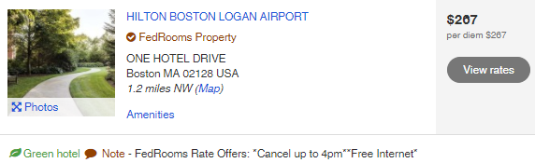

* FedRooms rates should be booked whenever available.
  + If a FedRooms rate is not available, a CWTSato Government Rate room should be booked.

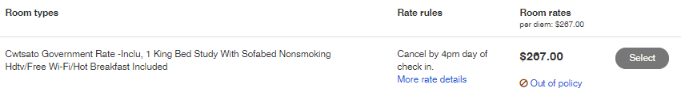

* If a FedRooms rate is available, and CWTSato rate is booked, you are allowed to book these rates, but an Out of Policy message may be received.

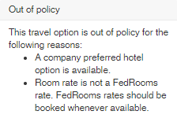

* If a Fedrooms rate or CWTSato rate is available, but a government rate is booked that is at or below per diem, you are allowed to book these rates, but an Out of Policy message may be received.
  + US Government hotel rates do not offer lenient cancellation policies or other benefits that are available when booking Fedrooms and CWTSato rates.





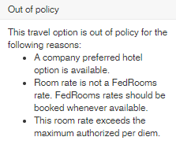

* If a hotel rate is booked above per diem, per the FTR and/or FAATP, this is considered out of policy and requires additional justification and approval. Adjustments will need to be made on the authorization to request approval for actual lodging expense when a hotel is booked above per diem.
* Additional remarks can be added to the travel authorization if necessary.

# State Tax Exemption Information

When you use a government card such as the "GSA SmartPay" travel card for business travel, your lodging and rental car costs may be exempt from state sales tax.

* **Centrally Billed Account (CBA) cards** are exempt from state taxes in EVERY state. Certain states require forms for CBA purchase cards and CBA travel cards.
* **Individually Billed Account (IBA) travel cards** are not exempt in all states. Certain states where IBA cards are exempt require forms.

Not sure if your travel card is CBA or IBA? Check on the [GSA SmartPay Website](https://www.gsa.gov/travel/plan-book/state-tax-exemption-information-for-government-charge-cards).

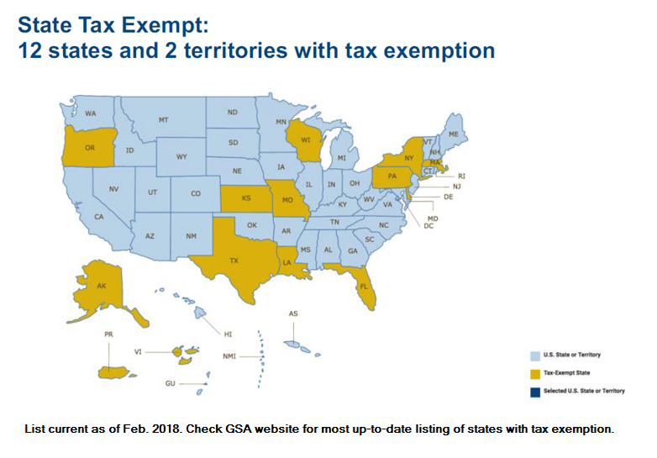

# Update Travel Charge Card

Currently when a TCC needs to be updated, the card must first be deleted from your profile, then added back as a new card. All travel charge card changes should be made from your E2 profile, and not your GetThere reservation profile. TCC updates made within GetThere will not be permanent and will need to be updated each time reservations are made. Follow the instructions below to correctly update your TCC within E2. If you require a travel charge card, but do not currently have one, contact your agency’s Travel Card Coordinator for assistance.

1. Click **Profile** on the task bar. The **User Profile** appears.
2. Scroll down the page, and click the **Edit Credit Card Information** link (in the Credit Card Information section). The **Credit Cards** page appears.

**TIP**: If the **Edit Credit Card Information** link does not appear in the profile, your workgroup travel policy requires an E2 administrator to handle all credit card information and activities; you cannot take any actions. Contact your E2 administrator or travel policy manager for assistance.

1. Delete the existing card information, and add the updated card information. (**This sequence of actions is necessary to conform to security requirements for the protection of personally identifiable information (PII).**)
2. Select the **Delete Card** check box to remove the existing card information.

**NOTE**: When selecting the **Delete Card** check box, charge card options for air, rail and hotel in the Online Booking Charge Card Defaults section will revert to "Select One".

1. Select default charge card options (*No Default* or *CBA (Centrally Billed Account)*) for air, rail and hotel in the Online Booking Charge Card Defaults section of the page.

**TIP**: If you are deleting your "Travel Charge Card" (or "Personal Charge Card"), selecting "Travel Charge Card" (or "Personal Charge Card", if applicable) as a default charge card option will result in an error.

1. Click **Save Changes**, and then click **OK** in the confirmation message box. Wait while information is updated.
2. Click the **Add ...** link for the card you want to update.
3. Enter and select your credit card details, including card type, card number and expiration date information.

**TIP**: Enter the card number without spaces or dashes. When updating travel charge card information, be sure the card type is correct. The error message "Travel Charge Card number does not have the required 4 digit prefix or meet the minimum required number of characters" indicates that the card number entered is not valid for the card type. If the card type selected is correct, check the card number entry for typographical errors.

1. Select default charge card options for air, rail and hotel guarantee in the Online Booking Charge Card Defaults section of the page.
2. Click **Save Changes**. This action also updates information in your TMC profile.

**TIP**: The new credit card information and default selections will apply to future reservations only. If you want these selections to apply to a pending reservation, contact your TMC for assistance.

# Find Answers / Online Help

Still need assistance with reservations or other E2 features? Additional support can be found by searching the E2 Knowledge Portal.

This section is full of step-by-step tutorials, interactive user guides, quick reference cards and other easily accessible information, by accessing the Online Help section. Online Help (formerly known as Find Answers) is available by selecting the drop down next to your name located in the upper right hand corner of the screen.

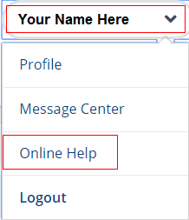

Once you’re in the E2 Knowledge Portal, type in your question or a keyword to locate all the information E2 has to offer regarding the subject, then select **Search**.

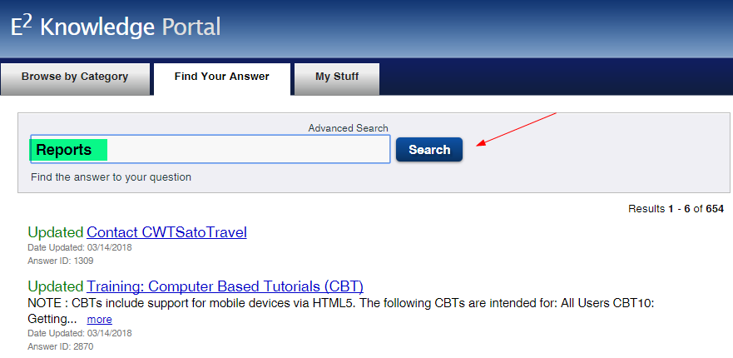

The E2 Knowledge Portal is a really great tool and can typically be used to locate an answer to whatever question you may have regarding E2 system functionality.

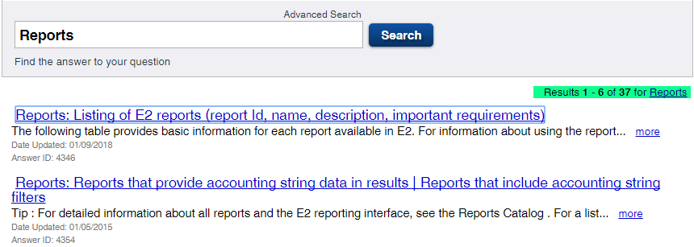

# ESC eTravel Contact Info

* If you have system questions or require assistance navigating within the E2, you may contact the ESC eTravel Help Desk team by phone or email:

[9-amc-etravel-helpdesk@faa.gov](mailto:9-amc-etravel-helpdesk@faa.gov) for system issues or questions or

1-866-641-3500, Option 7

(405) 954-5798 fax

* If you have questions regarding administrative changes or require assistance with completing an ESC eTravel form, you may contact the ESC eTravel Admin Team by email:

[9-amc-etravel-admin@faa.gov](mailto:9-amc-etravel-admin@faa.gov) for administrative changes

* Additional User Guides and Training, Access to E2 forms as well as a multitude of other Travel Information can be found by accessing the [ESC Travel Services Branch website](https://www.esc.gov/tsTravel.asp):

<https://www.esc.gov/tsTravel.asp>

# Travel Management Center (TMC) Contacts

|  |  |
| --- | --- |
| Agency | Phone Number |
| CPSC (CWTSato Travel) | (877) 327-5160 |
| CPSC VIP (CWTSato Travel) | (866) 214-1408 |
| CFTC (CWTSato Travel) | (877) 292-9187 |
| DOT (CWTSato Travel) | (877) 327-5164 |
| DOT VIP (CWTSato Travel) | (866) 740-7071 |
| FAA (CWTSato Travel) | (877) 327-5163 |
| FAA Alaska (El Sol) | (844) 565-4488 |
| IMLS (CWTSato Travel) | (877) 292-9190 |
| NEA (CWTSato Travel) | (877) 327-5161 |
| IMLS (CWTSato Travel) | (877) 292-9190 |
| SEC (CI Travel) | (855) 346-6711 |

# Fees

Fees for your agency can be viewed by locating the TMC for your agency. (FAA users who are located in Alaska use El Sol.)

## TMC Fees

* CI Travel TMC Fees (SEC Only)

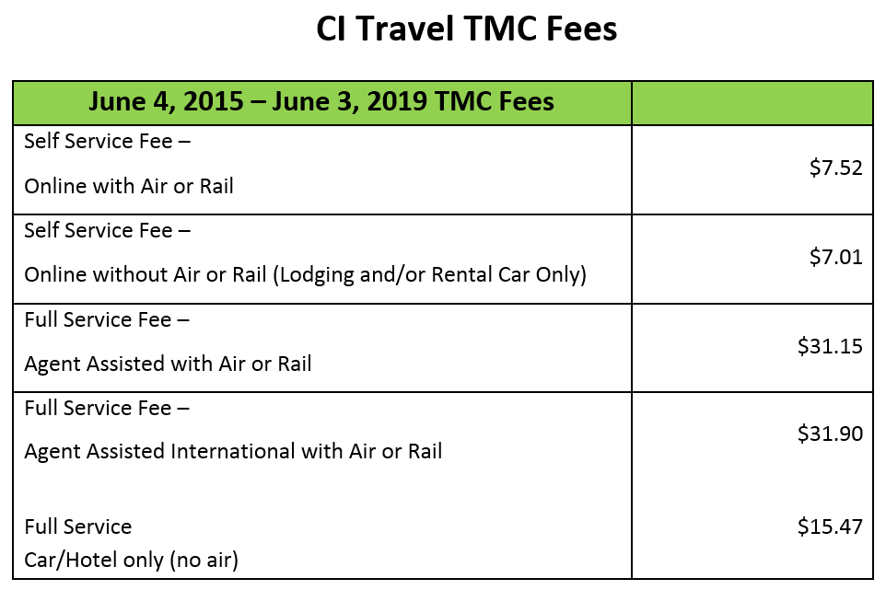

* CWTSato TMC Fees

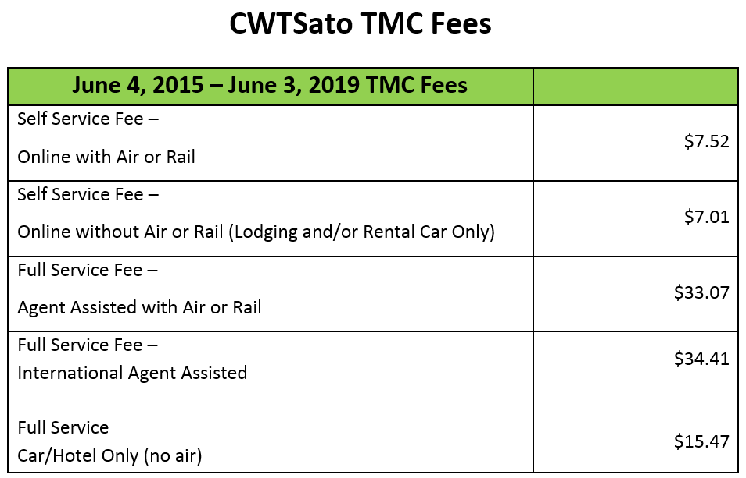

* El Sol TMC Fees (FAA Alaska Only)

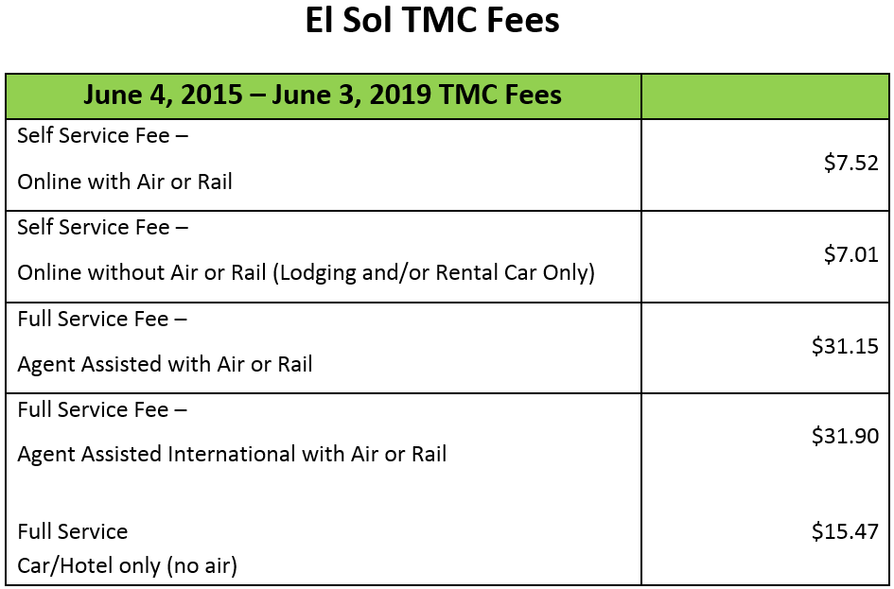

* Rodgers Travel TMC Fees (Volpe Only)

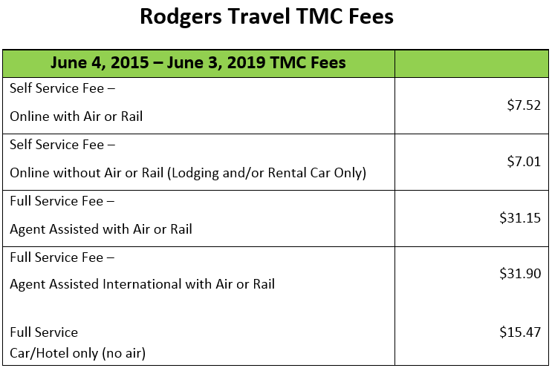

## Voucher Fees

* E2 Voucher Fees

