**5**

**Completing Accounting Information**

Use the Accounting page to select the lines of accounting to fund your trip.

1. Review the accounts selected to fund your trip.

* Click the **Select Account** Codes link to select the appropriate lines of accounting to fund your trip.
* If you need to allocate expenses to more than one line of accounting, add at least two account codes. Click the **Split Funding** link. This will be utilized when specific expenses or specific travel dates need to be charged to different lines of accounting.
* Click the Delete link to remove a specific line of accounting from the authorization.

1. Click **Next Step**.

**Completing Travel Policy Information**

**6**

This page displays items that may be outside your agency’s travel policy. If air, car, hotel or rail reservations are out of policy, you need to select a reason to justify the out of policy choices.

**7**

**Completing the Summary Step**

The Summary page displays your travel authorization information.

1. Review the authorization. Click the **Edit** Details link in the section header to return to that step to make changes.
2. When done, scroll down to the bottom of the summary page. Click the **Send to Approver** link.



Depending on your agencies policy, after your authorization is approved, your trip will be ticketed within two business days of the earliest departure date. You will receive an itinerary after booking and an invoice once ticketing occurs.

**Visit** [**https://www.esc.gov/tsTravel.asp**](https://www.esc.gov/tsTravel.asp) **to locate agency specific TMC and E2 Help Desk information.**

E2 Solutions is a trademark of CWT. All other marks are the property of their respective owners.

© 2012 – 2018 CWT. All rights reserved.

Updated April 4, 2018

|  |  |
| --- | --- |
|  | **Creating an Authorization** |

**Log into E2 Solutions**

1. Navigate to the website e2.gov.cwtsatotravel.com or login with your agency specific URL.
2. Enter your **E2 User ID** and **Password** and click **Login**.
3. If you do not have an E2 User ID and Password, contact your Travel POC. They’ll assist you with initiating a travel profile by submitting an eTravel User Profile Request to the ESC eTravel office.
4. Read and select **Accept** to the “Warning and Privacy Act Statement”; you will be taken to the **My** **E2** page.

**Creating a New Authorization**

See **UG25 Creating Authorizations** for more detailed information.

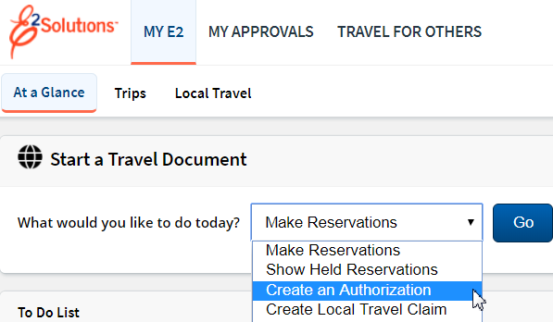

1. If you are creating an Authorization for yourself go to the **Start a Travel Document** section.Click the dropdown and select **Create an Authorization** then click **Go**.
2. If you are creating an Authorization for someone else, select the **Travel for Others** link at the top of your My E2 screen. Use the filter options that best fit your needs to locate the particular traveler. After selecting **Arrange** for the appropriate person, follow the instructions shown in step above.

**Completing Basic Information**

**1**

1. Enter the following on the Basic Information page:

* Type of Travel
* Specific Travel Purpose

1. Click **Save and Next Step.**

**2**

**Completing Reservations**

Use the Reservation page to:

* Make online flight, rental car, rail and hotel reservations
* Associate reservations with an authorization. If retrieving reservations made by traveler/arranger through the Shop First feature or retrieving reservations made by the Travel Management Center (TMC)
* Review reservations associated with the authorization

1. Review or make reservations.

The information that is first available on the Reservation page varies, depending on whether or not you have already associated reservations with your new authorization.

* If no reservations are associated with the authorization and you want to skip the reservation process, or if you have no actions available to you, click **Next Step** to continue.
* To make an online reservation now, click the **Make Reservations** link. After you book the reservations for your trip, you return to a refreshed Reservations page displaying your reservation details.
* If you made reservations using Shop First and chose to save the reservation for later, if you contacted the TMC for reservations or made reservations online that were sent to a travel agent, click the **Manage Trip Reservations** link to view all available reservations and select one or more to associate with the authorization. The Reservation page is blank until reservations are associated with the authorization.

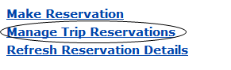

**Completing Reservations (Cont.)**

* If you made reservations using Shop First and chose to create an authorization after completing the booking process, the Reservation page displays the reservation details.



* **Reservation page with PNR data**

1. Click **Next Step**.

**3**

**Completing Site Details**

* If the authorization has associated reservations, the information on this page reflects the reservations details. You should review and verify that the per diem location is accurate.
* If you do not have or require reservations, or if the existing information is incorrect, complete the following required fields:

1. Complete the Begin information fields.
2. Complete the **End** information fields.
3. Click **Save and Next Step.**

* Under certain circumstances, you may want to add another site to your trip.

1. Click **Add** Site. This will add a site between your beginning and ending destinations. The Add Site section appears.
2. Verify or change the existing information.
3. Click **Save and Next Step**.

* Under certain circumstances, you may want to add a break to your trip. ***This is not common.***

1. Click **Add** Break. This will add a break between your beginning and ending destinations. The Add Break section appears.
2. Verify or change the **Break** information.

**Completing Site Details (Cont.)**

1. Verify or change the **Return from Break** information.

**4**

**Completing Expenses**

Use the Expenses page to review and update estimated expenses for the trip including:

* Lodging expenses for each site, including reimbursement types.
* Meals and incidental expenses (M&IE) for each site, including reimbursement types.
* Adding additional estimated expenses.
* Add TMC fees that were incurred for your trip. Currently this is a manual process. The TMC fees will not pull into your document automatically.

1. Review your estimated expenses. If you have an associated reservation, the fields on this page reflect the information from the reservation, and include airfare, rail, and lodging expenses (if applicable).

If you do not have an associated reservation, the lodging rates and M&IE are based on the per diem rates for the sites on your trip.

* Click the **Modify** link to edit the expense.
* Click the **Copy** link to copy the expense to another date.
* Click the **Delete** link to remove an estimated expense.
* Click the **Show** link to view expense details. (This link appears when you cannot update the information.)
* Click the **Add New Expense** link to add another estimated expense to the authorization.

1. Click **Next Step**.