Allow Itinerary Changes on a Final Voucher (without amending TA)

Background Information
This E2 enhancement was released into the E2 production environment on March 18, 2016.

Travelers and/or arrangers can change departure and return dates, sites and other itinerary information directly from a final voucher, without having to amend the authorization.

Instructions
- Go to Trips
- Locate the appropriate trip and select Show
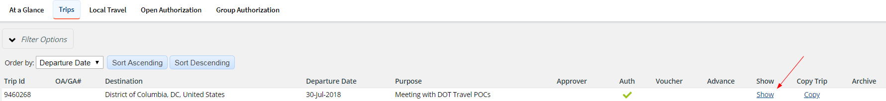
- The system will direct the user to their Trip Dashboard. Select Create Voucher.
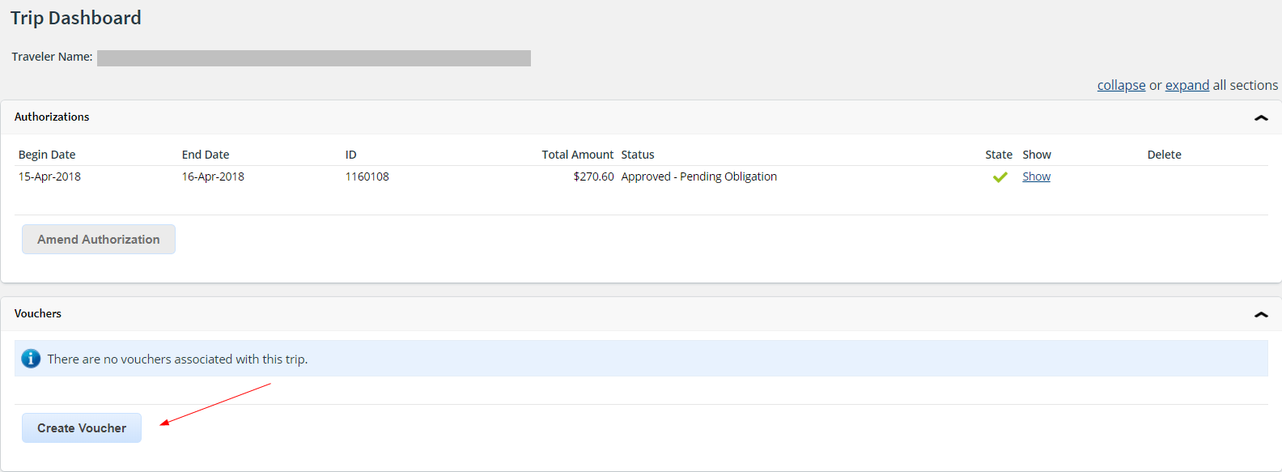
- Select Final Voucher and Update Site Details from the "For this trip this is the" selection list to insert a Site Details step in the voucher workflow. DO NOT change the End Date on Step 1: Basic Information page. If you do, you’ll receive the following error message after selecting Save and Next Step.
Select Save and Next Step. Then, make all itinerary changes on Step 2: Site Details page.
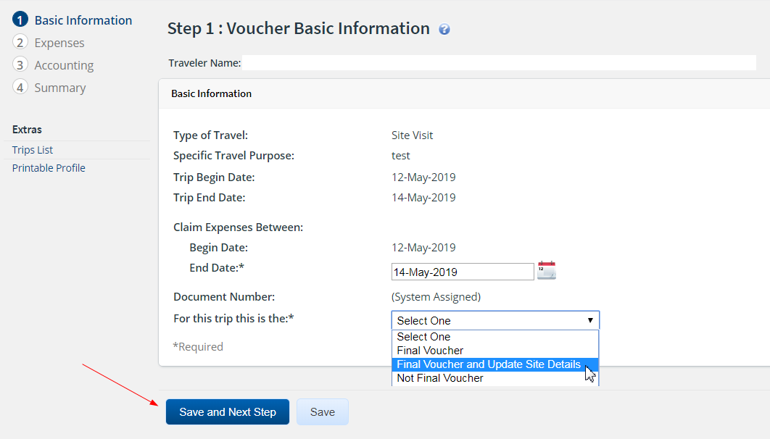
Voucher Basic Information page
The following rules apply:
- The voucher with itinerary changes becomes the final voucher for the trip.
- The traveler cannot make itinerary changes that impact trip vouchers that have already been submitted for approval or for expenses that were previously paid. All other site details changes are permitted.
- After saving the Basic Information page (Save and Next Step or Save), the traveler cannot change the voucher finality selection ("For this trip this is the" list selection changes to read-only). If the selection was made in error, delete the voucher and start again.
Tip: In some situations, itinerary changes may impact information that cannot be updated on the voucher, such as a reduced meals and incidentals expense amount. In this situation, the user should amend the authorization to include the itinerary changes and to update the related information. When the amended authorization is approved, the user can submit a standard "final voucher" for approval.

- An additional step will be added to the voucher workflow; Site Details. Make the necessary itinerary changes then select Save and Next Step to proceed. Finalize the voucher as normal.
