|  |  |
| --- | --- |
|  | **Approving Documents** |

Approvers review travel documents, ensuring that:

* The document is within travel policy.
* The correct lines of accounting have been selected to fund the travel expenses. You can make accounting changes if needed.
* For authorizations, approvers also verify that the expenses are correctly estimated, reimbursement types are correct, estimated expenses have been properly split between lines of accounting, and reservations are within policy.

**Log into E2 Solutions**

1. Navigate to the website e2.gov.cwtsatotravel.com or login with your agency specific URL.
2. Enter your **E2 User ID** and **Password** and click **Login**.
3. If you do not have an E2 User ID and Password, contact your Travel POC. They’ll assist you with initiating a travel profile by submitting an eTravel User Profile Request to the ESC eTravel office.
4. Read and select **Accept** to the “Warning and Privacy Act Statement”; you will be taken to the **My** **E2** page.

**Approving Document**

**1**

E2 provides access to approver functions through the **My Approvals** tab on the taskbar.

1. Click **My** Approvals. The default **Pending Approval** list shows all travel documents that are assigned to you for approval.

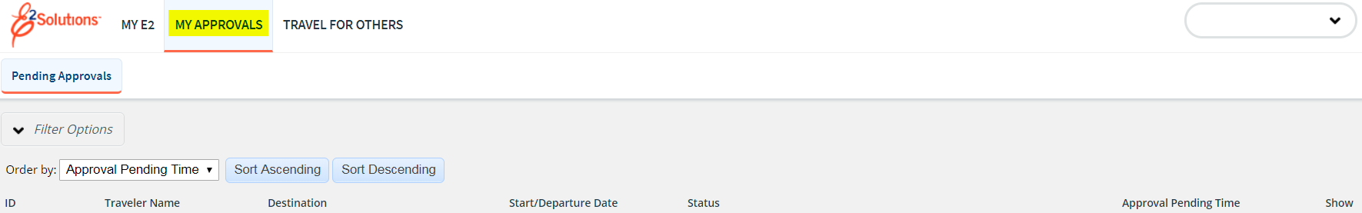

* **Pending Approval list on My Approval page**

1. Locate the document in the list and click the **Show** link to open. The summary page for that document appears. This view of the document is very similar to what the traveler sees when creating the document.



* **Voucher Summary Page**

1. Ensure that the document is locked to you. The document is locked if the **Unlock** link appears in the **OTHER ACTIONS** section. If the **Lock** link appears, the document is not locked to an approver. Click **Lock** to continue.
2. Use the **Summary** page to review each section of the document. If you need to see additional information or make changes to a section, click the **View Details** or **Edit Details** link for that section.
3. Approve, return or unlock the document.

* **Approve –** Click **Approve and Confirm.** In the case of warnings or errors that result in approval failure, contact your agency’s financial system help desk if you need assistance with these steps.
* **Return to traveler for revision**

1. Click **Return to Traveler.** The **Confirm Action** window appears.
2. Select the reason that you’re returning the document.
3. Enter your remarks and click **Confirm.**

* **Make the document available to another approver –** Click **Unlock.**

**Viewing Other Trip Related Documents**

**2**

**6**

**Trip Dashboard**

The dashboard displays a summary of all related documents. It also displays the status of these documents.

For example, the Trip Dashboard provides information about authorizations, comparative trips, vouchers and reservations for a specific trip.

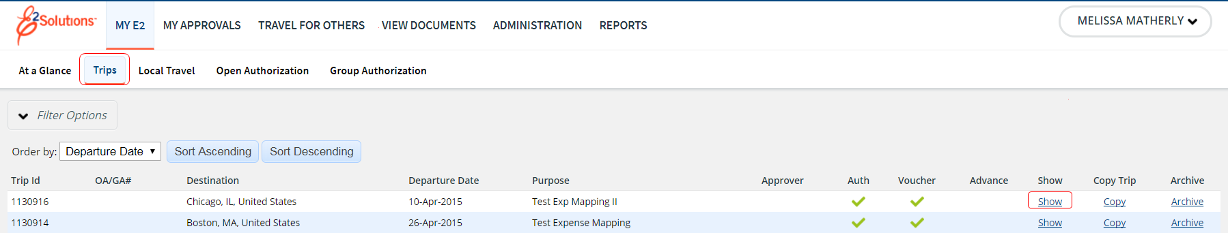

1. To access the trip dashboard, go to the **Trips** section.
2. Select **Show** next to the trip you wish to view.

The Trip Dashboard allows you to take a high level view of document statuses and other details.

**Actions that occur upon Approved status:**

* Airline tickets reserved through E2 Solutions will now be ticketed 2 business days before travel.
* Travel document is sent to the accounting system (Delphi) to be obligated if it is an authorization or to be paid if it is a voucher.

**Visit** [**https://www.esc.gov/tsTravel.asp**](https://www.esc.gov/tsTravel.asp) **to locate agency specific TMC and E2 Help Desk information.**

E2 Solutions is a trademark of CWT. All other marks are the property of their respective owners.

© 2012 – 2018 CWT. All rights reserved.

Updated April 4, 2018