* **Add a Travel Charge Card to Your E2 Profile**

1. Select **Profile**

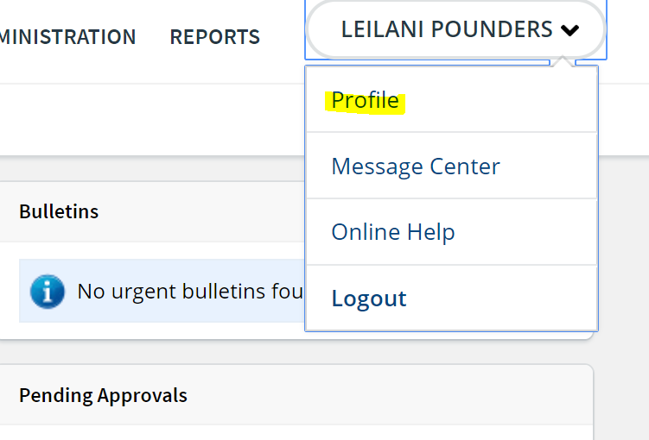

1. Scroll down and click the Edit Credit Card Information link (on the right side of the Credit Card Information section on the User Profile page). This displays the Credit Cards page.



*Figure 2: Credit Cards — No Available Card Information*

2. Add the information for your travel charge card in the Travel Charge Card section.

a. Select the type of travel charge card you are adding from the Type of Card drop-down list.

b. Enter the card number (without dashes or spaces) in the Card Number field.

***NOTE****: When you click* ***Save Changes****, the number entered in the* ***Card Number*** *field will be masked and display only the last four digits (e.g., XXXXXXXXXXXX1234).*

c. Select the card's expiration date using the **Expiration Date** drop-down lists. Select the month from the first drop-down list and the year from the second list.

3. Add the information for your personal credit card in the Personal Charge Card section.

a. Select the type of personal credit card you are adding from the **Type of Card** drop-down list.

b. Enter the card number (without dashes or spaces) in the **Card Number** field.

***NOTE****: When you click* ***Save Changes****, the number entered in the* ***Card Number*** *field will be masked and display only the last four digits (e.g., XXXXXXXXXXXX1234).*

c. Select the card's expiration date using the **Expiration Date** drop-down lists. Select the month from the first drop-down list and the year from the second list.

4. Select your default payment methods in the Online Booking Charge Card Defaults section.

***NOTE****: Available selections are limited by your travel policy and the card information entered above.*

a. Select one of the following options from the **Airfare Charge Card** drop-down list to indicate the default form of payment to use for airfare.

•

**CBA (Centrally Billed Account)** – Select this option to use the CBA for airfare charges.

**No default** – Select this option to indicate there is no default form of payment for airfare charges. You will be required to enter a travel charge card or CBA information each time you book travel reservations.

**Travel Charge Card** – Select this option to use your travel charge card for airfare charges.

***NOTE****: The* Travel Charge Card *option is only available if your agency's travel policy permits it, and if you have travel charge card information stored in your profile.*

b. Select one of the following options from the **Rail Charge Card** drop-down list to indicate the default form of payment to use for rail reservations.

•

**CBA (Centrally Billed Account)** – Select this option to use the CBA for rail charges.

**No default** – Select this option to indicate there is no default form of payment for rail charges. If selected, the TMC must contact you for billing information and you may be charged a full service TMC fee, even though you made the reservation online.

**Travel Charge Card** – Select this option to use your travel charge card for rail charges.

***NOTE****: The* Travel Charge Card *option is only available if your agency's travel policy permits it, and if you have travel charge card information stored in your profile.*

c. Select one of the following options from the **Hotel Guarantee Charge Card** drop-down list to indicate the default form of payment to use for hotel guarantees.

•

**No default** – Select this option to indicate there is no default form of payment for hotel guarantees. If selected, you may not be able to make hotel reservations

**Personal Credit Card** – Select this option to use your personal charge card for hotel guarantees. This option is only available if you have a personal charge card stored in your profile.

**Travel Charge Card** – Select this option to use your travel charge card for hotel guarantees. This option is only available if you have a travel charge card stored in your profile.

5. Click **Save Changes** to save your entries. Your online booking tool profile and the GDS are also updated with your entries/selections.

6. Click the **Back to Profile** link to return to the User Profile page.

**\*The new credit card information and default selections will apply to future reservations only. If you have pending reservations for which this should apply, contact your TMC for assistance.**

* **Modifying Existing Credit Card Information**

If you need to modify the information for a travel or personal charge card that was previously added to your profile, simply enter or select the new information in the appropriate section.

• All existing Online Booking Charge Card Defaults will remain in place and will not change unless you choose to update them.

• Any changes will also be sent to the GDS and the online booking tool to update your profile.

***TIP****: Be sure to click* ***Save Changes*** *to save your changes before returning to your profile!*

**\*The new credit card information and default selections will apply to future reservations only. If you have pending reservations for which this should apply, contact your TMC for assistance.**

* **Delete Existing Credit Card Information**

Click the trash can icon () in a section to remove that credit card information.

The **Type of Card** field is reset to *No Card on File*, and the **Card Number** and **Expiration Date** fields are cleared.

• Any existing Online Booking Charge Card Defaults for that card will also be removed, and the corresponding field(s) will revert to *Select One*. All other existing defaults, however, will remain in place and will not change unless you choose to update them.

• The card that was deleted will also be removed from your profile on the online booking tool and the GDS.

***TIP****: Be sure to click* ***Save Changes*** *to save your changes before returning to your profile!*