Authorizations | Reservations | Vouchers: Cancel trip

Updated 01/25/2016 10:10 AM

  Answer ID: 4070

I had travel plans, but they have been canceled. What should I do?

* **If the Cancel Trip link is available on the Trip Dashboard**, you can cancel your trip.

If the trip has associated reservations, you can choose to cancel the reservations or move them to your held reservations list for future use. If you need to submit certain expenses for reimbursement, a single voucher will be created for that purpose.

* **If the Cancel Trip link is not available**, the status of the documents associated with the trip do not allow the cancel action at this time.

For example, if you have sent a trip document to the approver and the approver has not yet taken any action, the document is in a Pending Approval status. The Cancel Trip option is not available if **any** trip document is in a Pending Approval status.

If there are documents (authorization, advance) in a Pending Approval status, you can [recall the documents](https://e2solutions-gov.custhelp.com/app/answers/detail/a_id/4216) (or you can ask the approver to return them to you), so you can cancel the trip.

**Tip**: Canceling a trip also cancels associated advances and vouchers.

To cancel a trip:

1. Access the Trip Dashboard. For example, click the My E2 **Trips** tab, locate the trip on the list and click **Show**.

If you are not taken directly to the Trip Dashboard, click the **Trip Dashboard** tab.

1. Click the **Cancel Trip** link in EXTRAS, on the left side of the page. A **Confirm Action** window appears.

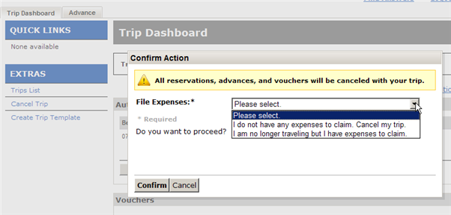

1. Make your **File Expenses** selection.
   * Select **I do not have any expenses to claim. Cancel my trip.** if you do not have any expenses to claim.
   * Select **I am no longer traveling but I have expenses to claim**. if you have some out-of-pocket expenses to claim, such as travel agent assistance fees, hotel deposits, airport parking or instant purchase airline tickets.

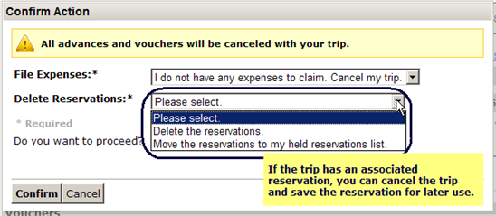

1. If the trip includes reservations, select the action from the **Delete Reservations** list.
   * To cancel the reservations, select **Delete the reservations**.
   * To save the reservations for later use, select **Move the reservations to my held reservations list**.
2. Click **Confirm**.

If you had expenses to claim, E2 creates a final voucher and takes you to the Voucher Basic Information page, so you can complete your voucher and submit your out-of-pocket expenses for approval.

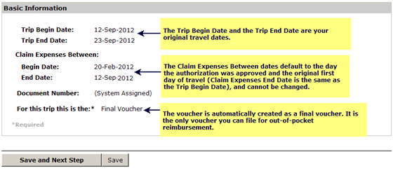

The Trip Begin Date and Trip End Date reflect your originally scheduled travel. The Claim Expenses Between dates default to the date the authorization was originally approved (Begin Date), and the first day of your original travel (End Date) and cannot be changed. (The Claim Expenses Between End Date is the same as the Trip Begin Date.) This allows you to claim out-of-pocket expenses between the approval of the trip and the original first day of travel. This is the only voucher you can file, and the system assigns it a voucher type of Final.

**Tip**: Do not delete the voucher; you will be unable to create another one. If you made the selection in error or no longer need to file out-of-pocket expenses for the canceled trip, submit the voucher with no expenses.

In some cases, your trip may move to a "Pending Cancelation" status. This is typically because cancellation of the reservation requires action from your travel management center (TMC). E2 will automatically update the status to "Canceled" when TMC action is complete. While the document is pending cancellation, you cannot take any actions on that document.

**Canceling an Amended Travel Authorization**

If you amend an authorization and/or remove or cancel reservations within this amended document you will not be able to cancel the authorization/trip until the document is sent through the approval process. You can zero out all expenses for and put a message in remarks for your approvers that state the cancel trip link is not available until the amended authorization has been approved. Once the document has been approved and obligated the cancel trip link will be available.

04/06/17